Investigating the effect of enhanced cleaning and disinfection of shared medical equipment on health-care-associated infections (CLEEN): a stepped-wedge, cluster randomised, controlled trial
Katrina Browne, Nicole M White, Philip L Russo, Allen C Cheng, Andrew J Stewardson, Georgia Matterson, Peta E Tehan, Kirsty Graham, Maham Amin, Maria Northcote, Martin Kiernan, Jennie King, David Brain, Brett G Mitchell.
Published online at Lancet Infectious Diseases https://doi.org/10.1016/S1473-3099(24)00399-2 © 2024. This manuscript version is made available under the CC-BY-NC-ND 4.0 license https://creativecommons.org/licenses/by-nc-nd/4.0/
Affiliations
School of Nursing and Health, Avondale University, Wahroonga, NSW, Australia (K Browne PhD, Prof P L Russo PhD);
Australian Centre for Health Services Innovation, School of Public Health and Social Work, Queensland University of Technology, Brisbane, QLD, Australia (N M White PhD, D Brain PhD);
Department of Infectious Diseases, Monash Health, Clayton, VIC, Australia (Prof A C Cheng PhD);
School of Clinical Sciences (Prof A C Cheng, P E Tehan PhD) and School of Nursing and Midwifery (Prof P L Russo, Prof B G Mitchell PhD), Monash University, Clayton, VIC, Australia;
Department of Infectious Diseases, The Alfred and School of Translational Medicine, Monash University, Melbourne, VIC, Australia (A J Stewardson PhD);
Cabrini Health, Malvern, VIC, Australia (Prof P L Russo);
School of Nursing and Health (G Matterson BBiotech, P E Tehan, Prof B G Mitchell) and Research Services (Prof M Northcote PhD), Avondale University, Cooranbong, NSW, Australia;
Central Coast Local Health District, Gosford, NSW, Australia (K Graham BNurs, M Amin MHlthLdr, J King PhD, Prof B G Mitchell);
Richard Wells Research Centre, University of West London, Brentford, UK (M Kiernan MClinRes);
School of Nursing and Midwifery, University of Newcastle, Gosford, NSW, Australia (J King);
Hunter Medical Research Institute, New Lambton Heights, NSW, Australia (Prof B G Mitchell).
Correspondence to: Prof Brett G Mitchell, School of Nursing and Health, Avondale University, Cooranbong, NSW 2265, Australia brett.mitchell@avondale.edu.au
Summary
Background There is a paucity of high-quality evidence based on clinical endpoints for routine cleaning of shared medical equipment. We assessed the effect of enhanced cleaning and disinfection of shared medical equipment on health-care-associated infections (HAIs) in hospitalised patients.
Methods We conducted a stepped-wedge, cluster randomised, controlled trial in ten wards of a single hospital located on the central coast of New South Wales, Australia. Hospitals were eligible for inclusion if they were classified as public acute group A according to the Australian Institute of Health and Welfare, located in New South Wales, had an intensive care unit, had a minimum of ten wards, and provided care for patients aged 18 years or older. Each cluster consisted of two randomly allocated wards (by use of simple randomisation), with a new cluster beginning the intervention every 6 weeks. Wards were informed of their allocation 2 weeks before commencement of intervention exposure, and the researcher collecting primary outcome data and audit data was masked to treatment sequence allocation. In the control phase, there was no change to environmental cleaning practices. In the intervention phase, a multimodal cleaning bundle included an additional 3 h per weekday for the dedicated cleaning and disinfection of shared medical equipment by 21 dedicated cleaning staff, with ongoing education, audit, and feedback. The primary outcome was the number of confirmed cases of HAI, as assessed by a fortnightly point prevalence survey and measured in all patients admitted to the wards during the study period. The completed trial is registered with Australia New Zealand Clinical Trials Registry (ACTRN12622001143718).
Findings The hospital was recruited on July 31, 2022, and the study was conducted between March 20, 2023, and Nov 24, 2023. We assessed 220 hospitals for eligibility, of which five were invited to participate, and the first hospital to formally respond was enrolled. 5002 patients were included in the study (2524 [50·5%] women and 2478 [49·5%] men). In unadjusted results, 433 confirmed HAI cases occurred in 2497 patients (17·3%, 95% CI 15·9 to 18·8) in the control phase and 301 confirmed HAI cases occurred in 2508 patients (12·0%, 10·7 to 13·3) in the intervention phase. In adjusted results, there was a relative reduction of –34·5% (–50·3 to –17·5) in HAIs following the intervention (OR 0·62, 95% CI 0·45 to 0·80; p=0·0006), corresponding to an absolute reduction equal to –5·2% (–8·2 to 2·3). No adverse effects were reported. Interpretation Improving the cleaning and disinfection of shared medical equipment significantly reduced HAIs, underscoring the crucial role of cleaning in improving patient outcomes. Findings emphasise the need for dedicated approaches for cleaning shared equipment.
Funding National Health and Medical Research Council.

Research in context
Evidence before this study
Microorganisms can survive in the hospital environment for long periods of time, including on shared medical equipment, posing an ongoing source for potential transmission. We searched MEDLINE (PubMed), the Cochrane Database, and the Cumulative Index to Nursing and Allied Health Literature for English-language, peer-reviewed articles published between Jan 1, 2005, and Dec 31, 2022. We selected studies (ie, cohort, observational, and experimental) conducted in hospitals that examined exposure or acquisition from previous room occupants who were colonised or infected with a specific organism and assessed quality using risk of bias tools. Our systematic review and meta-analysis, suggests that admission to a hospital room previously occupied by a patient who was infected or colonised with a pathogen is a risk factor for acquisition, highlighting the role of the environment as a reservoir for further transmission. In a previous systematic review by Peters and colleagues, the authors identified four randomised controlled trials, which showed the importance of improving both routine cleaning and discharge cleaning on the incidence of health-care-associated infections. Only four trials have been conducted in this area to date, emphasising the dearth of high-quality evidence in this area and, more broadly, in infection prevention and control.
The review by Peters and colleagues also identified that no randomised controlled trials have explored the value of improving the cleaning of shared medical equipment on health-care-associated infections, despite genomic studies identifying shared medical equipment as an important transmission route in the hospital environment.
Added value of this study
To our knowledge, this is the first randomised controlled trial to evaluate the effect of improving the cleaning of shared medical equipment on the incidence of health-care-associated infections. Our intervention requires no new technology. In hospitals globally, lack of clarity about who is responsible for cleaning of shared medical equipment is common and translates to infrequent cleaning. Our study provides evidence for the first time that improving cleaning of shared medical equipment reduces health-care-associated infections.
Implications of all the available evidence
The findings from this pragmatic study provide novel evidence that dedicated cleaning time, auditing, and providing feedback to cleaning staff improved the thoroughness of cleaning for shared medical equipment and resulted in a reduction of health-care-associated infections.

Introduction
Health-care-associated infections (HAIs) substantially affect patients who receive care in hospital through increased mortality and morbidity as well as health services through increased length of stay, diagnostic costs, and treatment costs.1 Increasing levels of antimicrobial resistance exacerbate these challenges.2,3 Implementing robust, evidence-based prevention programmes is crucial to mitigate these risks and promote patient safety.
Health-care environments harbour a diverse microbial community, with pathogens persisting on surfaces for extended periods, creating a reservoir for transmission.4 A systematic review and meta-analysis emphasised this risk by identifying an increased risk of colonisation or infection, or both, in patients occupying rooms that were previously inhabited by colonised individuals.5 Randomised controlled trials showed that improving routine and discharge cleaning reduced the incidence of HAIs.6,7 However, despite whole-genome sequencing showing the transmission of pathogens via shared medical equipment, there is a paucity of strong evidence based on clinical endpoints for routine cleaning of shared medical equipment.8,9 Uncertainty exists in health-care systems, locally and globally, about who is responsible for cleaning shared equipment, leading to variation in policy and a lack of cleaning.10–12 Providing high-quality evidence might quantify the relative importance of cleaning shared equipment, providing important data for which effective cleaning models can be developed and evaluated.
The aim of our Cleaning and Enhanced Disinfection (CLEEN) study was to evaluate the efficacy of enhanced cleaning and disinfection of shared medical equipment in reducing the prevalence of HAIs.
Methods
Study design and participants
We performed a stepped-wedge, cluster randomised, controlled trial across ten wards in one large public hospital located on the central coast of New South Wales, Australia, over a 36-week period from March 20, 2023, to Nov 24, 2023 (figure 1; appendix p 3). The study design comprised five treatment sequences, with two wards randomised to each sequence to ensure a sufficient sample size per cluster. One cluster switched from control to intervention every 6 weeks. Outcomes were measured across all clusters every 2 weeks, assuming continuous recruitment with short exposure.13 A protocol for this study has been published.14
All hospitals in New South Wales were screened for eligibility against the study inclusion criteria. Hospitals were eligible for inclusion if they were classified as a public acute group A hospital by the Australian Institute of Health and Welfare; located in New South Wales; had an intensive care unit; had a minimum of ten wards; provided care for adult patients (ie, aged ≥18 years); and were willing to participate in the study (appendix p 3). Eligible wards within the hospital were required to have at least 20 beds and care for adult patients. Hospitals were excluded if they were opening, closing, relocating, or implementing major environmental cleaning initiatives or changes within the study timeframe. A purposive sampling method (ie, non-probability sampling) was used (appendix p 3). The research team approached five hospitals that met the eligibility criteria to gauge interest in participating. These hospitals were invited first based on existing relationships with members of the team. The study was funded for one hospital, and the first hospital to agree to participate was selected.
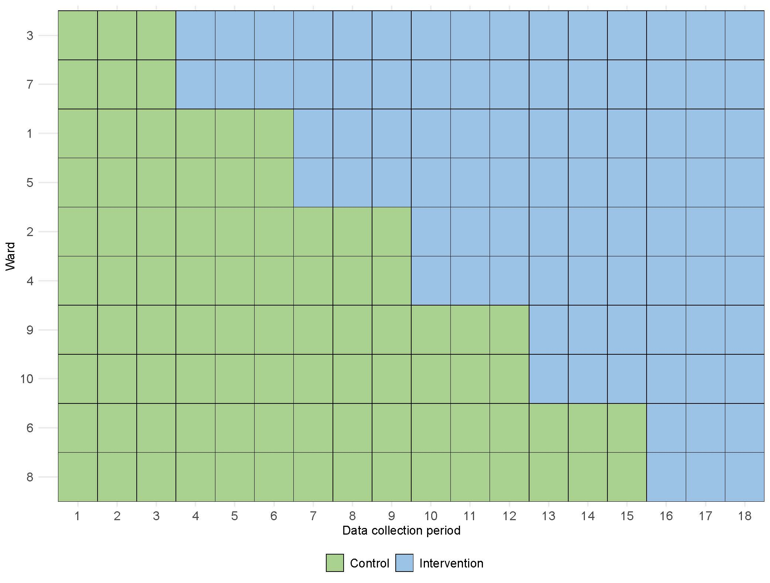
Figure 1. Stepped-wedge trial design. Each data collection period represents a 2-week period.
The stepped-wedge design allowed all clusters to be exposed to the intervention and supported feasible rollout within a complex environment. A stepped-wedge design was considered most appropriate for this study, as wards could act as their own control, thus reducing the effects of potential confounders. This design also allowed time for the research staff to work with individual wards and cleaning staff involved in the study. This approach maximised consistency of implementation. This trial was approved by the Hunter New England Human Research Ethics Committee including a waiver of individual patient consent (2022/ETH01780). Site-specific authorisation for the study was granted by the participating hospital. The completed trial is registered with Australia New Zealand Clinical Trials Registry (ACTRN12622001143718).
Randomisation and masking
Randomly assigning wards to study design sequences was done independently by the trial statistician (NMW) with R, version 4.0.3. Participating wards were assigned an integer value from one to ten, which were then randomised to sequences one to five by use of a set seed. The statistician was not involved in data collection or the determination of outcomes. Simple randomisation was completed for all wards before trial commencement. Sequence allocations were known to the statistician and the trial coordinator and were not available to the participating wards or staff involved in data collection. Each participating ward was informed of their allocation 2 weeks before the commencement of intervention exposure. This concealment process was undertaken by the trial coordinator. The researcher collecting primary outcome data (ie, HAI data) and audit data was masked to the treatment sequences for the entirety of the study. Unmasking of the data to the research team did not occur until analysis was completed.
Procedures
The multimodal intervention consisted of dedicated cleaning and disinfection of shared medical equipment, education on cleaning techniques, and auditing of cleaning thoroughness with feedback to staff. The study period was aligned to span three full seasons: autumn (ie, March, April, and May), winter (ie, June, July, and August), and spring (ie, September, October, and November), with the study midpoint corresponding to the usual epidemiological peak for respiratory infection in the region (ie, July).
In the control phase, there was no requirement for cleaning staff to clean shared medical equipment. During the intervention phase, 3 h of additional cleaning per weekday was provided to each ward. The additional cleaning was undertaken by dedicated cleaners in adjunct to the routine clean-between-use model for clinical staff. We used dedicated cleaners to reduce the risk of treatment contamination and to aid consistency in implementation. The additional cleaning focused on specific shared medical equipment, including commodes, blood pressure monitors, infusion drip stands, and pumps (appendix p 4). Shared medical equipment was items found on all ten wards, used by multiple patients or related to patient care, stored in common areas, that contacted intact skin and were defined as non-critical. Dual detergent-disinfection wipes registered with the Therapeutic Goods Administration were used to clean equipment (Clinell universal15 and sporicidal16 wipes, GAMA Healthcare, Melbourne, VIC, Australia). These wipes are recorded as effective against a range of bacteria and viruses by the Therapeutic Goods Administration.15,16 For equipment that had been cleaned but was in storage ready for use, a bright label was applied so that clinical staff knew it had been cleaned (appendix p 4).
Before commencement of the intervention, 21 dedicated cleaning staff undertook a 1-h training and education seminar, spread over many months and sessions due to the stepped-wedge design. The seminars were delivered in person by a postdoctoral scientist with experience in hospital environmental cleaning and education. The training materials were reviewed by the manufacturer of the cleaning products. Training sessions focused on the principles of cleaning and disinfection with practical experience of cleaning shared medical equipment, following the manufacturer’s guidelines where available. Refresher training sessions were given every 12 weeks of the intervention or when audit results showed that cleaning thoroughness was below 50%.
During the study period, fluorescent marker gel dots were used to audit whether a piece of equipment was cleaned, based on previous protocols.17 Once dried, the dots were invisible to the naked eye, resistant to dry abrasion, and completely removed by routine cleaning. A randomised list of 12 pieces of shared medical equipment was generated for each audit, to gain a scope of equipment across the study period (appendix p 4). Every ward was audited each fortnight, during which a fluorescent marker dot was placed on a frequent touch point on 12 pieces of shared medical equipment (appendix p 7). The equipment was visually inspected under ultraviolet light 24–36 h after placement of fluorescent marker gel, allowing the opportunity for the equipment to be cleaned at least once. A piece of equipment was considered cleaned if the fluorescent mark was totally removed. During the intervention phase, results from audits were reported verbally to cleaning staff during their next shift, followed by a fortnightly email further explaining audit results. Audit results were used to improve the proportion of equipment cleaned. Posters were placed in dedicated cleaning staff rooms each month, with results and goals for the next month (appendix p 6). The fidelity of the intervention was evaluated by a signed daily record of additional cleaning hours per ward and the number of training sessions delivered.
Data were collected for all patients admitted to a participating ward before or at 0800h on the survey day and not discharged from the ward at the time of the survey. An HAI was defined as an infection that was acquired as a direct or indirect result of health care and was confirmed to have been acquired more than 48 h after admission to the health-care facility or with symptoms presenting 48 h after admission, 28 days after admission for Clostridioides difficile infections, 30 days from the date of surgery, and 90 days from the data of surgery if the patient’s infection was associated with a surgical implant.18 For the collection of HAI outcome data, a data extraction tool in Research Electronic Data Capture (REDCap, hosted by Hunter Medical Research Institute) was developed and piloted before the study.19,20 This tool was adapted from a previous multicentre point prevalence study.21 The researcher who collected data was trained in the use of the survey instrument and the definitions used. Following a review of medical, pathology, and microbiology records, the presence of an HAI was determined by use of an algorithm applying the HAI definitions used in the European Centre for Disease Prevention and Control protocol, version 5.3.18 The attribution of an HAI to a specific ward was determined through a 48-h timeframe (ie, the infection occurred more than 48 h after ward admission) and defined rules (appendix p 8). Intra-reliability and inter-reliability was evaluated in addition to a validation process during the study (appendix p 8). Sex data were collected by the hospital staff on admission, and the options were male or female. Ethnicity data were not collected by the hospital. Within our study, an experienced qualitative researcher and interviewer (MN) also interviewed cleaners in a focus group discussion to explore their experience of the intervention and determine preferences for receiving feedback (appendix p 37).
Outcomes
The primary outcome was defined as the number of confirmed cases of HAI measured in all participants who were admitted to the ten wards during the study period. The primary outcome was measured every 2 weeks by use of a standardised, validated point prevalence survey, including all confirmed HAIs. Patients were counted more than once if they had more than one separate admission during the study period. The secondary outcomes of the study were prespecified subgroup analyses of the types of HAIs from data collected for the primary outcome, the thoroughness of cleaning for shared medical equipment, defined as the proportion of fluorescent marker dots that were completely removed during the fortnightly audits, the preferences of staff for receiving feedback on cleaning, and the cost-effectiveness of the intervention. The cost-effectiveness evaluation is a substantial piece of work and will be reported separately. Adverse events were recorded by the hospital as per usual reporting. Sensitivity analyses were performed to assess the influence of study design and analysis assumptions on outcome estimates.
Statistical analysis
A statistical analysis plan was prepared and published before data analysis.22 Sample size calculations were based on a complete stepped-wedge design, adjusted for variation in cluster sizes.23 The baseline HAI prevalence of 11% was calculated based on previous work.21 The minimum sample size per cluster-time step to detect a reduction in the primary outcome of 35% or more was 132 patients for an expected 80% power. Calculations assumed a two-sided 5% level of statistical significance, an intra-cluster correlation of 0·3, and a coefficient of variation of 0·65. We used generalised linear mixed models to analyse primary and secondary outcomes at the ward level. The models assumed a binomial dependent variable and a logit link function to associate fortnightly ward outcomes with intervention exposure. A random intercept was specified to account for within-ward correlation. Fortnightly data collection periods were modelled as a categorical fixed effect to adjust for background trends that were independent of intervention exposure. A linear effect was used for cases where initial models did not converge due to data sparsity.
Statistical analyses were performed in R, version 4.0.3. Intervention effectiveness for the primary outcome was modelled as a binary independent variable, which was equal to 0 for the control phase and first week of intervention exposure in a ward and 1 otherwise. Three forms of intervention fixed effects were trialled for the secondary outcome: a binary effect, a linear effect, and a combined binary–linear effect. These specifications were informed by a previous study, which tested the assumption of a step-change in cleaning performance (binary), a gradual change over intervention exposure time (linear), and a combined step-change with gradual changes over intervention time (binary–linear).6 Model goodness-of-fit was compared across the three specifications by Akaike’s Information Criteria. Generalised linear mixed model results were reported as odds ratios (ORs) with 95% CIs and p values based on two-sided Wald hypothesis tests. Parametric bootstrapping was applied to examine uncertainty in model-based outcome prediction by study phase (ie, control or intervention), as well as relative and absolute percentage changes associated with intervention exposure, after accounting for cluster and background time trends.
Secondary outcome data from fortnightly cleaning audits were analysed with a binomial generalised linear mixed model with model specification as per the primary outcome. For the intervention fixed effect, a binary, linear, and combined binary–linear specification were trialled and compared for goodness-of-fit. A detailed description of the analyses performed can be found in the statistical analysis plan.22
Infections for prespecified subgroup analyses were chosen based on the likelihood of their spread via environmental contamination and pilot work that was done before study commencement to test data collection processes. Bloodstream infections, urinary tract infections, pneumonias, and surgical site infections were combined and assessed. Additionally, all confirmed cases of HAI (ie, primary outcome) excluding cases of COVID-19 were assessed, because the role of fomite transmission in the spread of COVID-19 is uncertain. Our third category of infections included in subgroup analyses were all HAIs (ie, primary outcome) excluding eye, ear, nose, mouth, and throat infections. This category was included because eye, ear, nose, mouth, and throat infections appeared to have a higher prevalence in this hospital than in previously reported studies. Full details can be found in our statistical analysis plan.22
Prespecified sensitivity analyses assessed changes in estimated intervention effectiveness based on individual wards being excluded (leave-one-out analysis), delays in intervention effectiveness (2 weeks or 4 weeks), and choice of link function (logit vs log vs identity). Results from the identity link were used to estimate trial intra-cluster correction to inform future studies.
Role of the funding source
The funder of the study had no role in study design, data collection, data analysis, data interpretation, or writing of the report.
Results
We assessed 220 hospitals for eligibility between Jan 10 and June 3, 2022, of which 22 hospitals were eligible for participation in this study, five were initially invited to participate, and one hospital was enrolled in the study (figure 2). The participating hospital was recruited on July 31, 2022, and had approximately 500 beds, providing services that included haematology and oncology as well as vascular, respiratory, orthopaedic, and plastic surgery. The ten wards within this hospital were randomly assigned to a sequence on Feb 7, 2023.
There were two deviations to the protocol. In the intervention, only 2159 (79·1%) of 2730 h of additional cleaning shifts were staffed. In the final 2 weeks of the study, ward 4 was closed for urgent repairs and no data were recorded for data collection period 18 or included in analysis.
5002 patients were included in the study: 2494 (49·9%) in the control phase and 2508 (50·1%) in the intervention phase (table 1). Most patients were emergency admissions. There were no substantial differences in participant characteristics between the control and intervention phases. Three patients had separate admissions in the control phase and are recorded only once in the baseline demographic information. Each separate admission was recorded in the point prevalence survey.
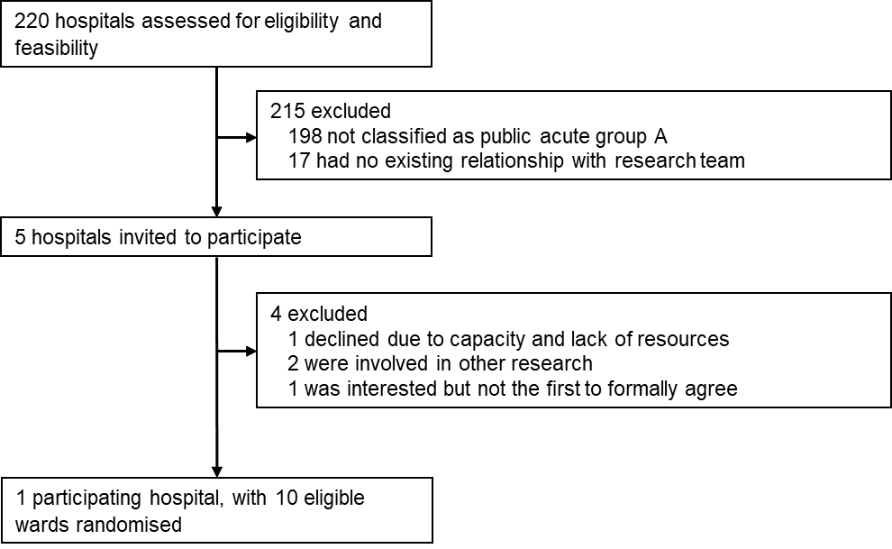
Figure 2. Trial profile.
Table 1. Baseline characteristics for all patients and stratified by HAI acquisition.
Characteristic | All patients (%) | Patients without HAI (%) | Patients with ≥1 HAI (%) | Control (%) | Intervention (%)
Total patients | 5,002 | 4,417 | 585 | 2,494 | 2,508
Sex: Male | 2,478 (49.5%) | 2,182 (49.4%) | 296 (50.6%) | 1,240 (49.7%) | 1,238 (49.4%)
Sex: Female | 2,524 (50.5%) | 2,235 (50.6%) | 289 (49.4%) | 1,254 (50.3%) | 1,270 (50.6%)
Median age in years (IQR)  Mean age in years (SD) | 75 (63 to 83)  71.6 (16.1) | 75 (63 to 83)  71.4 (16.3) | 75 (66 to 83)  73.2 (14.0) | 75 (63 to 83)  71.4 (15.9) | 75 (63 to 84)  71.9 (16.3)
Emergency Admission | 4,159 (83.1%) | 3,710 (84.0%) | 449/585 (76.8%) | 2,055 (82.4%) | 2,104 (83.9%)
Current colonisation or infection with multi-resistant organism | 610 (12.2%) | 485 (11.0%) | 125 (21.4%) | 339 (13.6%) | 271 (10.8%)
Ward length of stay prior to survey | 7 (3 to 16)  15.8 (34.4) | 6 (3 to 14)  14.7 (33.1) | 14 (8 to 27)  24.2 (41.7) | 7 (3 to 17)  16.8 (39.3) | 7 (3 to 15)  14.8 (28.6)
Peripheral vascular access device present | 2,347 (46.9%) | 2,052 (46.5%) | 295 (50.4%) | 1,192 (47.8%) | 1,155 (46.1%)
Central vascular access device present | 316 (6.3%) | 225 (5.1%) | 91 (15.6%) | 176 (7.1%) | 140 (5.6%)
Indwelling urinary catheter present | 785 (15.7%) | 645 (14.6%) | 140 (23.9%) | 406 (16.3%) | 379 (15.1%)
Ventilated | 415 (8.3%) | 343 (7.8%) | 72 (12.3%) | 197 (7.9%) | 218 (8.7%)
Ward specialty: Geriatric | 530 (10.6%) | 472 (10.7%) | 58 (9.9%) | 101 (4.0%) | 429 (17.1%)
Ward specialty: Neurology | 555 (11.1%) | 503 (11.4%) | 52 (8.9%) | 195 (7.8%) | 360 (14.4%)
Ward specialty: Oncology | 588 (11.8%) | 480 (10.9%) | 108 (18.5%) | 425 (17.0%) | 163 (6.5%)
Ward specialty: Orthopaedic | 519 (10.4%) | 460 (10.4%) | 59 (10.1%) | 412 (16.5%) | 107 (4.3%)
Ward specialty: Other | 1 (0.0%) | 1 (0.0%) | 0 (0.0%) | 0 (0.0%) | 1 (0.0%)
Ward specialty: Renal | 442 (8.8%) | 388 (8.8%) | 54 (9.2%) | 174 (7.0%) | 268 (10.7%)
Ward specialty: Respiratory | 586 (11.7%) | 532 (12.0%) | 54 (9.2%) | 311 (12.5%) | 275 (11.0%)
Ward specialty: Surgical | 1,675 (33.5%) | 1,488 (33.7%) | 187 (32.0%) | 828 (33.2%) | 847 (33.8%)
Ward specialty: Vascular | 106 (2.1%) | 93 (2.1%) | 13 (2.2%) | 48 (1.9%) | 58 (2.3%)
Data are n (%) unless otherwise stated. Three patients had two separate admissions to hospital, where they acquired separate infections, and are recorded only once in the baseline demographic information.

No policy changes, such as screening and isolation, or reported outbreaks occurred during the study period. Hand hygiene compliance stayed relatively constant in the lead-up to and throughout the study (appendix p 30). Colonisation pressure, as measured by the number of patients under transmission-based precautions, did not change throughout the study (appendix p 32). Over the entire intervention phase, 2159 (79·1%) of 2730 h of rostered cleaning were fulfilled (appendix p 7).
For the primary outcome, in unadjusted results HAI prevalence in all wards combined was higher in the control phase than in the intervention phase (table 2, figure 3). There were differences between people who acquired an HAI and those who did not in: the length of hospitalisation before the point prevalence survey, presence of devices, and colonisation or infection with a multidrug resistant organism (table 1). 123 patients had more than one HAI during their admission, with 86 in the control phase and 37 in the intervention phase.
Table 2. Unadjusted prevalence of HAIs in control and intervention phases by ward.
Ward | Control |  |  | Intervention
Ward | Patients | HAIs | % HAI prevalence  (95% CI) | Patients | HAIs | % HAI prevalence (95% CI)
1 | 189 | 23 | 12.2  (7.5 to 16.8) | 359 | 37 | 10.3  (7.1 to 13.5)
2 | 276 | 58 | 21.0  (16.2 to 25.8) | 275 | 32 | 11.6  (7.9 to 15.4)
3 | 82 | 9 | 11.0  (4.2 to 17.7) | 393 | 36 | 9.2  (6.3 to 12.0)
4* | 314 | 37 | 11.8  (8.2 to 15.4) | 278 | 29 | 10.4  (6.8 to 14.0)
5 | 161 | 24 | 14.9  (9.4 to 20.4) | 314 | 48 | 15.2  (11.3 to 19.3)
6 | 401 | 60 | 15.0  (11.5 to 18.5) | 73 | 11 | 15.1  (6.9 to 23.2)
7 | 91 | 18 | 19.8  (11.6 to 28.0) | 430 | 44 | 10.2  (7.4 to 13.1)
8 | 340 | 54 | 15.9  (12.0 to 19.8) | 65 | 12 | 18.5  (9.0 to 27.9)
9 | 321 | 96 | 29.9  (24.9 to 34.9) | 160 | 32 | 20.0  (13.8 to 26.2)
10 | 322 | 54 | 16.8  (12.7 to 20.9) | 161 | 20 | 12.4  (7.3 to 17.5)
All wards | 2,497† | 433 | 17.3  (15.9 to 18.8) | 2,508 | 301 | 12.0  (10.7 to 13.3)
HAI=health-care-associated infection. *Ward 4 was relocated in the last week of the study to a new area in the hospital. The ward and patients on the ward were excluded from the final 2 weeks of the study. †Three patients had two separate admissions each, and are therefore counted twice here.
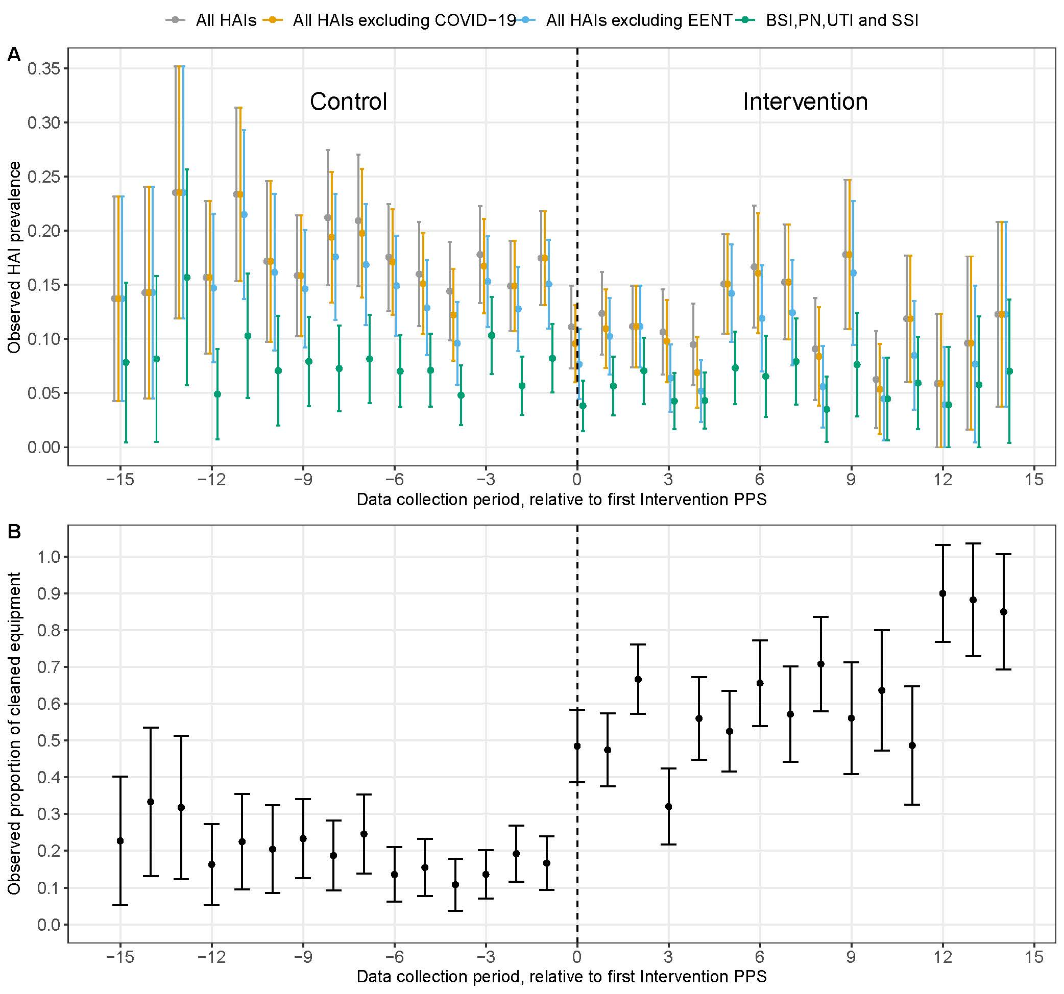
Figure 3. Summary of outcomes relative to the first intervention PPS. HAI prevalence (A) and proportion of cleaned equipment (B) in the control phase and intervention phase by HAI subtype. Each data collection period represents a 2-week period. EENT=ear, eye, nose, and throat infection. HAI=health-care-associated infection. PPS=point prevalence survey. SSI=surgical site infection. UTI=urinary tract infection.
In adjusted results, there was a significant reduction in all HAIs, from 14·9% (95% CI 10·4 to 19·4) in the control phase to 9·8% (6·1 to 14·1) in the intervention phase (OR 0·62, 95% CI 0·45 to 0·80; p=0·00056). These results correspond to an absolute difference of –5·2 percentage points (95% CI –8·2 to –2·3) and a relative difference of –34·5 percentage points (–50·3 to –17·5; (table 3).
In all prespecified subgroup analysis, the intervention was associated with reduced combined bloodstream infections, urinary tract infections, pneumonias, and surgical site infections; HAIs, excluding COVID-19; and HAIs, excluding eye, ear, nose, mouth, and throat infections (table 3).
During the study, 1786 individual pieces of shared medical equipment (925 in the control phase and 861 in the intervention phase) were audited. In unadjusted results, the proportion of equipment cleaned increased from 168 of 925 (18·2%, 95% CI 15·7–20·6) in the control phase to 487 of 861 (56·6%, 53·3–59·9) in the intervention phase. Progressive increases in the proportion of equipment cleaned were seen across the study period (figure 3). In adjusted results, the predicted cleaning thoroughness increased from 24·3% (15·7–33·2) in the control phase to 65·6% (51·6–77·1) 0 weeks after intervention exposure (OR 5·94, 95% CI 4·13–8·55; p<0·0001) in the binary plus linear model (appendix p 22). The predicted cleaning thoroughness increased after 2 weeks of exposure to 68·1% (54·9–79·0; 1·06, 1·01–1·11; p=0·020).
Our interviews conducted with cleaning staff during the focus group discussion on Nov 2, 2023, showed that cleaners reported that receiving feedback verbally or through email was preferred; they did not like public displays of feedback (appendix p 37).
Table 3. Estimated changes in HAI point prevalence attributable to the intervention. Model-based bootstrap results, showing predicted outcomes by study phase and absolute and relative differences in prevalence (intervention – control), after accounting for clustering and secular time trends. EENT=ear, eye, nose, throat, and mouth infection. HAI=health-care-associated infection. OR=odds ratio. SSI=surgical site infection. UTI=urinary tract infection.
Outcome | Control %  (95%CI) | Intervention %  (95%CI) | OR  (95%CI) | Absolute Difference %  (95%CI) | Relative Difference %  (95%CI) | p-value (Intervention vs. Control)
All HAIs | 14.9  (10.4 to 19.4) | 9.8  (6.1 to 14.1) | 0.62  (0.45 to 0.80) | -5.2  (-8.2 to -2.3) | -34.5  (-50.3 to -17.5) | 0.0006
BSI, PN, UTI and SSI | 6.3  (3.3 to 9.6) | 4.0  (1.9 to 6.8) | 0.62  (0.42 to 0.86) | -2.3  (-4.3 to -0.7) | -36.2  (-56.1 to -12.8) | 0.013
All HAIs excluding COVID-19 | 14.4  (10.2 to 19.0) | 9.0  (5.7 to 13.4) | 0.59  (0.45 to 0.77) | -5.3  (-8.1 to -2.7) | -37.2  (-51.3 to -19.5) | 0.0002
All HAIs excluding EENT | 13.0  (8.6 to 17.4) | 8.3  (4.9 to 12.0) | 0.60  (0.45 to 0.81) | -4.8  (-7.6 to -2.1) | -36.7  (-51.7 to -17.4) | 0.0008

There were no adverse events reported and no safety issues associated with the intervention. We found no evidence of equipment degradation due to the intervention (appendix p 36).
In prespecified sensitivity analyses, we completed leave-one-ward-out analysis for all HAIs and for each subgroup (appendix p 14) with graphical presentation of predicted and secular trends (appendix p 17) and modelled different delayed intervention effects (ie, no delay, 2 weeks, and 4 weeks; appendix p 15). For leave-one-ward- out analysis, significant reductions in infections remained for the primary analysis and for all subgroup analysis in most instances, except for when three wards were individually excluded from analysis for combined bloodstream infections, urinary tract infections, pneumonias, and surgical site infections and when one ward was excluded from analysis for all HAIs excluding COVID-19. Modelling delays in the intervention effect produced similar results for estimated absolute and relative differences for the primary analysis and subgroup analysis; however, results for combined bloodstream infections, pneumonias, urinary tract infections, and surgical site infections under a delayed effect were not significant. After accounting for overdispersion in sensitivity analysis, the estimated change in proportion of equipment cleaned was greater at intervention commencement compared with during the control phase (OR 6·42, 95% CI 3·97–10·38; p<0·0001) followed by smaller gains after 2 weeks of exposure (1·02, 0·97–1·07; p=0·45; appendix p 29).
Discussion
This RCT showed that a multimodal intervention involving system change, education, audit, and feedback was efficacious in increasing the thoroughness of cleaning of shared medical equipment and reducing the prevalence of HAIs. In the control phase, the prevalence of HAIs was 14·9% (95% CI 10·4–19·4) of patients had an HAI. During the cleaning intervention, the HAI prevalence was reduced to 9·8% (6·1–14·1). In sensitivity analysis, results remained mostly consistent, with a few exceptions. Our study indirectly supports the role of fomite transmission in HAIs and supports the cleaning of shared medical equipment as a key intervention strategy to prevent many types of HAIs.
The study reaffirms the importance of a clean clinical environment and has implications for patient safety. In the past, there has been a focus on the visual appearance of cleanliness, for example, dusting, as opposed to the current focus on reducing bioburden through cleaning and disinfection. Consistent with existing practice before the trial and the approach commonly used in hospitals more broadly, in the control phase of our study, it was the responsibility of health-care workers to clean shared patient equipment after use. Cleaners were not responsible for cleaning these pieces of equipment. We identified relatively low levels of cleaning thoroughness during the control phase. Low proportions of equipment cleaned during the control phase suggest that routine cleaning is either not performed or is ineffectively performed. The efficacy of our intervention might partly be a result of low levels of cleaning thoroughness in the control phase, but we contend that our results are generalisable to hospitals globally, particularly where there is a lack of responsibility and accountability for cleaning shared equipment.10–12 Our study did not assure that multiple-use items were cleaned in between every patient, rather the intervention assured a minimum standard of once a day. It is also possible that clinicians observing the extra cleaning were either more motivated than usual to clean in between uses or less motivated, where an assumption of cleanliness is made and so routine cleaning is deemed not necessary. Routine cleaning of multiple-use equipment does not form part of routine audits of cleanliness, and so we have shown that assuring at least a minimum standard of a daily clean can affect HAIs. The reduction in HAIs that was associated with our intervention might be due to reduced bioburden, reduced burden of infectious pathogens, a dedicated daily clean being performed more effectively than cleaning in between patients, or a combination of these reasons. Cleaning done by clinical staff in between patients might be improved during the intervention phase, due to increased focus on cleaning; however, our intervention did not target clinical staff. An advantage of using dedicated cleaners was that we could ensure there was sufficient time and expertise to clean equipment. Additionally, feedback from audits was not provided to clinical staff, nor was education.
The implementation of our study reflects some practical challenges; for example, there were reductions in thoroughness of cleaning in three time periods during the study due to staffing constraints (figure 3). Interestingly, these reductions in thoroughness corresponded to increases in HAI prevalence during the same or subsequent periods. When implementing our intervention in other settings, a key strategy will be to allocate responsibility of cleaning equipment and provide sufficient time and resources for this task. Additionally, ensuring training for staff responsible for cleaning is important, with a recognition of the time needed to clean and decontaminate equipment between uses.
Implementing our intervention is relatively straightforward, involving additional cleaning and disinfection of shared medical equipment with a wipe. An important component of our multimodal intervention was the audit and feedback to cleaning staff, consistent with other studies.6,17 We are also completing an economic evaluation of this study, the results of which will help to inform decisions about adoption in the context of finite healthcare budgets and sustainable models in the future. Whereas we used an approach of dedicated additional cleaning delivered on the ward, other potential approaches exist, such as a centralised approach to cleaning shared equipment, including the use of various technologies. The sustainability of this intervention relies on the multimodal design, including regular training, education, audit, and feedback. Clear accountability of roles and responsibilities and adequate staff resourcing will also improve the sustainability of the intervention.
Our study has limitations. The study was conducted at a single site, where HAIs were high compared with other hospitals.21 The results at this site might not be replicated when implemented in different hospital settings, particularly intensive care units, because we did not include an intensive care unit in our study. Nonetheless, we believe that our study is generalisable, because the cleaning of shared medical equipment is a challenge faced by hospitals globally. Moreover, the shared medical equipment used in this study is also commonly found other health-care settings, such as aged care facilities, rehabilitation centres, and community medical practices. Although we show a reduction in HAIs following the cleaning intervention, we did not complete whole-genome sequencing of environmental samples to definitively prove transmission pathways. This approach was not feasible for our trial due to the associated labour and financial constraints. A limitation of stepped-wedge design is addressing secular trends. We sought to address this limitation by modelling underlying trends and accounting for them in analysis. Additionally, administrative coding data (ie, ICD-10) for infections that is routinely collected in Australian hospitals show no historical trends before our trial or in the time period that our trial was conducted in (appendix p 35). We collected data on potential confounders, such as hand hygiene and colonisation pressure, with no important changes; however, comorbidity- related data was not collected at an individual participant level (appendix pp 30–33).
In conclusion, we report the first RCT to show that enhanced cleaning and disinfection of shared medical equipment can reduce HAIs. The intervention can be adopted by other health-care facilities to improve the cleaning of shared equipment. Adoption of this intervention might involve the use of dedicated teams or the expansion or modification of cleaning responsibilities.
Contributors
BGM developed the concept, was the chief investigator, and acquired funding for the study. The methodology was designed by BGM, PLR, AJS, AC, and NMW. KB was the study coordinator responsible for project administration and implementation. BGM, PLR, AJS, ACC, and MK supervised the study. Study visualisation was performed by BGM, NMW, and KB. Additional resources were provided by MA and KG. Software was managed by PET, NMW, and KB. Investigation was performed by GM, KB, BGM, PET, MA, KG, and MN. Data validation was performed by KB, GM, and PET. BGM, NMW, and KB curated the data. BGM and NMW had access to the raw data. NMW and BGM accessed and verified the data and performed the formal analysis. BGM, KB, and NMW wrote the first draft of the manuscript. GM, ACC, AJS, JK, PLR, PET, MN, MK, and DB revised the draft critically for important intellectual content. All authors approved the final version of the article. BGM was responsible for the decision to submit the manuscript. All authors had full access to all the data in the study and had final responsibility for the decision to submit for publication.
Declaration of interests
BGM declares grants from GAMA Healthcare paid to their institution; consulting fees from ICS Service Solutions paid to their institution; honoraria for their role as Editor-in-Chief of Infection, Disease and Health and from the Australasian College for Infection Prevention and Control; non-financial leadership roles within the Australian Government (Commonwealth) National Health and Medical Research Council, the National Infection Control Guidelines Committee, and the Australian Infection Control Guidelines expert group; and receipt of Clinell wipes from GAMA Healthcare provided to their institution. ACC declares grant funding from the National Health and Medical Research Council and the Australian Government Department of Health; consulting fees from the Therapeutic Goods Administration; participation on advisory boards for non-pharmaceutical trials (on the topic of prevention of infections in haematological malignancy); a past role as President of the Australasian Society for Infectious Diseases; and other non-financial interests in the Australian Infection Control Guidelines expert group. PET declares grants from the Urgo Foundation, the Australian Podiatry Association, the Department of Health and Aged Care, Wounds Australia, and the Australian Podiatry Education Research Foundation. MK declares former part-time consultant contracts from GAMA Healthcare and support for attending conferences from GAMA Healthcare, including travel expenses and accommodation. MK was an invited speaker at the conferences and did not receive any honoraria amount. AJS, DB, GM, JK, KB, KG, MA, MN, NMW, and PLR declare no competing interests.
Data sharing
Participant data reported in this article are subject to ethics and privacy restrictions. The conditions of ethics approval do not allow us to distribute or make available these data directly to other parties. Applications for data access should be made by contacting BGM. The study protocol, statistical analysis plan, and associated resources are freely available online for researchers to access at http://www.cleenstudy.com. We have posted the coding for our analysis on GitHub at https://github.com/nicolemwhite/CLEEN_study.
Acknowledgments
This project was funded by a National Health and Medical Research Council Emerging Leadership Investigator grant awarded to BGM, administered by Avondale University (GNT2008392). We thank Hunter Research Medical Institute (Newcastle, NSW, Australia) for their support. We thank the cleaning staff for their hard work and dedication to this study. We thank our peer reviewers (Joshua Davis, Alistair McGregor, and Jason Kwong) for critically reviewing our paper before submission.
References
- Haque M, Sartelli M, McKimm J, Abu Bakar M. Health care associated infections—an overview. Infect Drug Resist 2018;11: 2321–33.
- Dadgostar P. Antimicrobial resistance: implications and costs. Infect Drug Resist 2019; 12: 3903–10.
- Chinemerem Nwobodo D, Ugwu MC, Oliseloke Anie C, et al. Antibiotic resistance: the challenges and some emerging strategies for tackling a global menace. J Clin Lab Anal 2022; 36: e24655.
- Porter L, Sultan O, Mitchell BG, et al. How long do nosocomial pathogens persist on inanimate surfaces? A scoping review. J Hosp Infect 2024; 147: 25–31.
- Mitchell BG, McDonagh J, Dancer SJ, et al. Risk of organism acquisition from prior room occupants: an updated systematic review. Infect Dis Health 2023; 28: 290–97.
- Mitchell BG, Hall L, White N, et al. An environmental cleaning bundle and health-care-associated infections in hospitals (REACH): a multicentre, randomised trial. Lancet Infect Dis 2019; 19: 410–18.
- Anderson DJ, Chen LF, Weber DJ, et al. Enhanced terminal room disinfection and acquisition and infection caused by multidrug resistant organisms and Clostridium difficile (the Benefits of Enhanced Terminal Room Disinfection study): a cluster randomised, multicentre, crossover study. Lancet 2017; 389: 805–14.
- Peters A, Schmid MN, Parneix P, et al. Impact of environmental hygiene interventions on healthcare-associated infections and patient colonization: a systematic review. Antimicrob Resist Infect Control 2022; 11: 38.
- Lee AS, White E, Monahan LG, Jensen SO, Chan R, van Hal SJ. Defining the role of the environment in the emergence and persistence of vanA vancomycin-resistant enterococcus (VRE) in an intensive care unit: a molecular epidemiological study. Infect Control Hosp Epidemiol 2018; 39: 668–75.
- Anderson RE, Young V, Stewart M, Robertson C, Dancer SJ. Cleanliness audit of clinical surfaces and equipment: who cleans what? J Hosp Infect 2011; 78: 178–81.
- Peters A, Otter J, Moldovan A, Parneix P, Voss A, Pittet D. Keeping hospitals clean and safe without breaking the bank; summary of the Healthcare Cleaning Forum 2018. Antimicrob Resist Infect Control 2018; 7: 132.
- Dancer SJ. Hospital cleaning in the 21st century. Eur J Clin Microbiol Infect Dis 2011; 30: 1473–81.
- Copas AJ, Lewis JJ, Thompson JA, Davey C, Baio G, Hargreaves JR. Designing a stepped wedge trial: three main designs, carry-over effects and randomisation approaches. Trials 2015; 16: 352.
- Browne K, White N, Tehan P, et al. A randomised controlled trial investigating the effect of improving the cleaning and disinfection of shared medical equipment on healthcare-associated infections: the CLEaning and Enhanced disiNfection (CLEEN) study. Trials 2023; 24: 133.
- Therapeutic Goods Administration. GAMA Healthcare Australia Pty Ltd—Clinell universal wipes—disinfectant, hospital grade (447250). https://www.tga.gov.au/resources/artg/447250 (accessed July 31, 2022).
- Therapeutic Goods Administration. GAMA Healthcare Australia Pty Ltd—Clinell sporicidal granules—disinfectant, hospital grade (332520). https://www.tga.gov.au/resources/artg/332520 (accessed July 31, 2022).
- Carling PC, Von Beheren S, Kim P, Woods C. Intensive care unit environmental cleaning: an evaluation in sixteen hospitals using a novel assessment tool. J Hosp Infect 2008; 68: 39–44.
- European Centre for Disease Prevention and Control. Point prevalence survey of healthcare-associated infections and antimicrobial use in European acute care hospitals—protocol version 5.3. Stockholm: European Centre for Disease Prevention and Control, 2016.
- Harris PA, Taylor R, Thielke R, Payne J, Gonzalez N, Conde JG. Research electronic data capture (REDCap)--a metadata-driven methodology and workflow process for providing translational research informatics support. J Biomed Inform 2009; 42: 377–81.
- Harris PA, Taylor R, Minor BL, et al. The REDCap consortium: building an international community of software platform partners. J Biomed Inform 2019; 95: 103208.
- Russo PL, Stewardson AJ, Cheng AC, Bucknall T, Mitchell BG. The prevalence of healthcare associated infections among adult inpatients at nineteen large Australian acute-care public hospitals: a point prevalence survey. Antimicrob Resist Infect Control 2019; 8: 114.
- White N, Cheng A, Browne K, et al. A randomised control trial investigating the effect of improving the cleaning of shared medical equipment on healthcare-associated infections (the CLEEN study): statistical analysis plan. medRxiv 2023; published online Dec 21. https://doi.org/10.1101/2023.12.20.23300169 (preprint).
- Hooper R, Teerenstra S, de Hoop E, Eldridge S. Sample size calculation for stepped wedge and other longitudinal cluster randomised trials. Stat Med 2016; 35: 4718–28.

