Promoting visible learning through using Graphic Organisers

Sarah Hanley
Head of Humanities & Classroom Teacher, Gilson College, Taylors Hill, VIC

“Your life as a teacher begins the day you realise that you are always a learner”
Robert John Meeham

I have given this quote much thought throughout my eight years in the teaching profession. It has stimulated my curiosity to try new initiatives in the classroom and has challenged the way I view my role as an educator. As a teacher at Gilson College, I have been given the opportunity to participate and reflect upon my teaching practices through annual Action Research projects. Each year, staff members identify an area of their teaching pedagogy they wish to explore in more detail, undertake research into current academic theories, participate in professional learning conversation with colleagues and then implement a range of teaching strategies in the classroom with the intention of improving teacher practice and student learning. This reflective process has enabled me to come to the conclusion that I am a lifelong learner who must take chances to grow and reflect upon my professional practice, to continually develop my professional capacity, and ultimately, to improve and enhance student learning. As a result of this, throughout the course of 2017 I have embarked on a journey to unlock students’ knowledge and understanding, and make it more visible through the use of graphic organisers.

What are graphic organisers?

Graphic organisers are visual learning strategies that guide student thinking and enhance their understanding of subject matter. They can be used as tools to organise, simplify and scaffold students’ thoughts and ideas. Learners can use graphic organisers to visually display connections and correlations between facts and concepts. These tools can also be used to prompt and stimulate students’ thinking skills and to guide the structure of their responses to learning tasks such as research projects or assessments. The organisers also provide an avenue for making students’ learning visible to the teacher and their peers.

Using graphic organisers in my classroom

During recent units of work on Medieval Europe & the Black Death, I wanted to provide my Year 8 Humanities students with opportunities to become independent and active learners who are confident and capable individuals. With this goal in mind, I knew I had to unlock their higher order and critical thinking skills and give them practical tools that helped them to think deeply, as well as develop the ability to connect key concepts. Over the course of four weeks, students used a variety of graphic organisers such as Mind Mapping for organising and linking concepts, Cause and Effect Charts when displaying relationships between phenomena, and Venn diagrams to support comparing and contrasting.

As the teaching and learning sequence proceeded and after I assessed the data produced from the students’ learning tasks, one thing became apparent: every student was able to demonstrate though his or her graphic organisers, deeper thinking skills, as well as meaningful learning. Their graphic organiser summaries had guided them to construct and generate more effective written and oral responses. The data also revealed that all students in the class had become more active learners who were better able to understand new material. They were also able to delve into more critical thinking by expanding upon key topics in detail and establish connections between different concepts.

Using the graphic organisers was also a great way to integrate ICT to enhance student engagement. My students used a number of iPad apps, such as Popplet, Total Recall or SimpleMind which enabled them to brainstorm key ideas, create timelines to sequence events, and time periods, as well as giving them the ability to transform their knowledge into visual representations that they were able to share with others. Using these apps also allowed students to take information they had internalised and transform it into visual representations that visibly displayed their learning.

Important considerations

There is a large number of graphic organisers available to teachers. It is imperative that teachers select and utilise templates appropriate for the purpose of the teaching and learning that is to occur; organisers that will generate specific thinking, understandings and skills. For example, if teachers want students to develop their ability to sequence events and connect ideas, a timeline, flowchart, cycle circle or mind map could be beneficial. Alternatively, if teachers want to improve students’ ability to compare and contrast, a Venn diagram or Y chart might be useful.

Advantages of using graphic organisers

The major advantage of using graphic organisers to scaffold student learning is that they can be used by all students regardless of their learning abilities, and can therefore assist teachers to differentiate for their students. Every student can use the templates at their individual point of need, using them to breakdown and/or extend their knowledge, understanding and skills. Learners will benefit from visually seeing connections and relationships between facts and other information. The organisers then allow students to reflect upon essential information and classify and arrange content in a way that is meaningful to them. By using graphic organisers, students are also able to develop vital comprehension skills as well as connect newly acquired information to existing knowledge, and prior understanding to then make informed statements and judgements about the topic at hand.

Implications for classroom teachers

Graphic organisers are useful tools that can assist teachers to formatively and summatively assess student learning. Educators are able to observe and record students’ understanding, provide immediate and ongoing feedback and feed-forward, as well as identify areas or specific concepts that need more explicit teaching. These organisers are also easily adaptable to any course material for any learning area or year level. Teachers can use the organisers as ways of differentiating students’ abilities and empowering each individual learner to succeed. The content developed by students within the graphic organisers provides a ‘snapshot’ of where each student is at in terms of their learning, their understanding, knowledge and thinking skills. This data can then be used teachers to drive continuous learning and assist in future planning.

Conclusion

My 2017 Action Research Project, ‘Promoting Visible Learning Through Using Graphic Organisers’, has enabled me to realise that graphic organisers are important teaching tools that teachers can use to guide students’ deep thinking. Using graphic organisers in the classroom has not only enabled me to make my students thinking more visible, but it has enriched classroom learning and fostered student growth and development; for that I will be forever grateful.

In addition, this project has helped me to come to the conclusion that for teachers to be effective in our craft, we must actively pursue and seek out opportunities to help us grow in our professional practice; we must utilise innovative and inclusive practices that will engage our students in the learning process. It is essential that we equip students with a range of skills that will help them succeed in the world around them, and graphic organisers are one such tool.

For more information, further readings and worksheets please see the websites below

References:

- 'Teaching and Learning with Graphic Organisers': Introduction to Graphic Organisers', Inspiration Software Inc. Retrieved April 20, 2017 from
http://www.inspiration.com/visual-learning/graphic-organizers
- ‘Graphic Organizers’, Teacher Vision. Retrieved April 20, 2017 from https://www.teachervision.com/lesson-planning/graphic-organizer
- ‘Graphic Organisers’, Department of Education, Victorian State Government. Retrieved April 20, 2017 from
http://www.education.vic.gov.au/school/teachers/support/Pages/graphicorganisers.aspx
- ‘Graphic Organisers’, The Teacher Toolkit. Retrieved April 26, 2017 from
http://www.theteachertoolkit.com/index.php/tool/graphic-organizers
- ‘Graphic Organizers’, Enchanted Learning. Retrieved April 26, 2017 from
http://www.enchantedlearning.com/graphicorganizers/
- ‘Being a Lifelong Learner’, This Education, Gareth Lewis. Retrieved April 26, 2017 from
https://thiseducationblog.wordpress.com/2015/12/13/being-a-lifelong-learner/
Classroom Photos

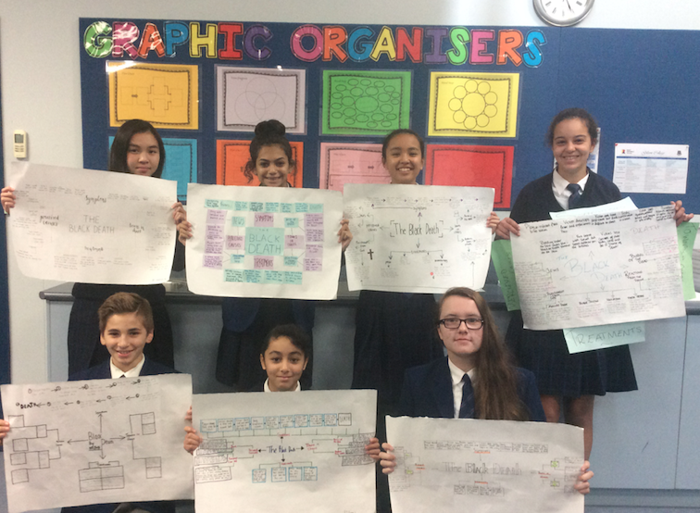

Figure 1: Students of 8AB displaying their mind maps of the Black Death
(left to right- Kathy, Angelica, Tulip, Hope, Nelson, Karen & Alissa)

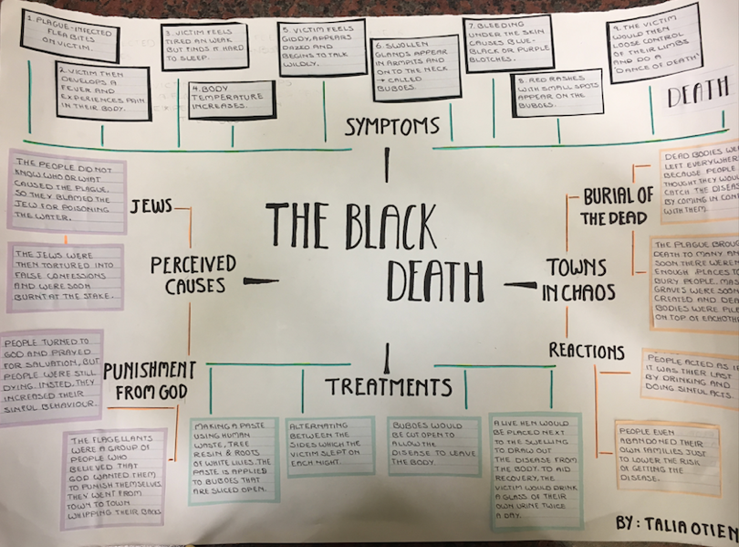

Figure 2: Student work sample of mind mapping the key concepts associated with the Black Death- by Talia

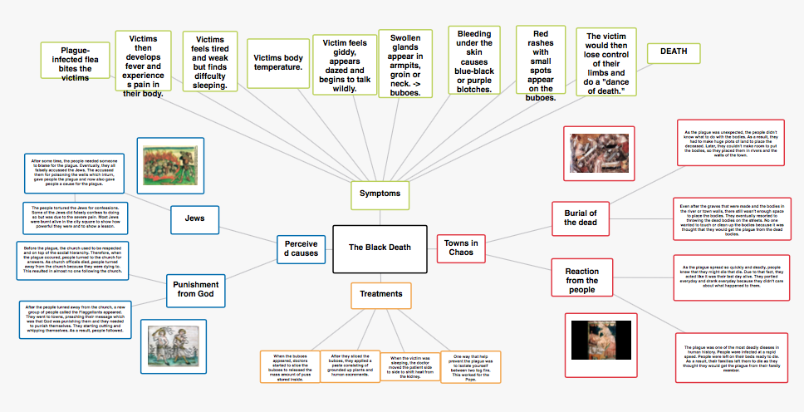
Figure 3: Student work sample of mind mapping, using the Popplet app- by Ayden

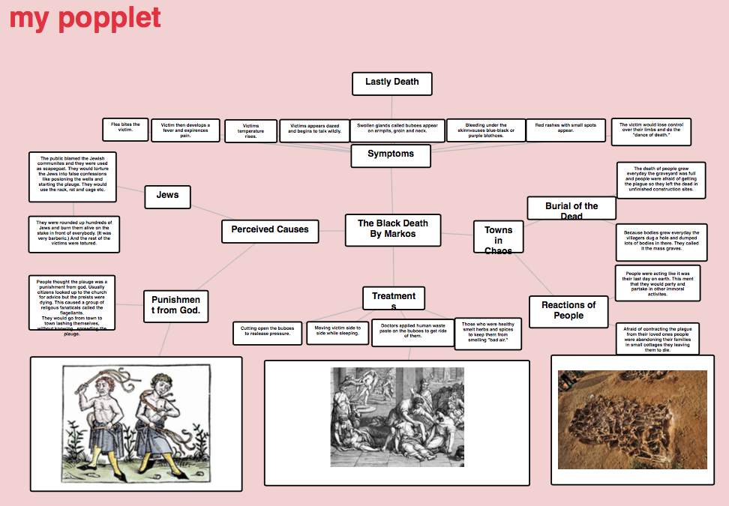
Figure 4: Another student work sample of mind mapping, using the Popplet app- by Markos.

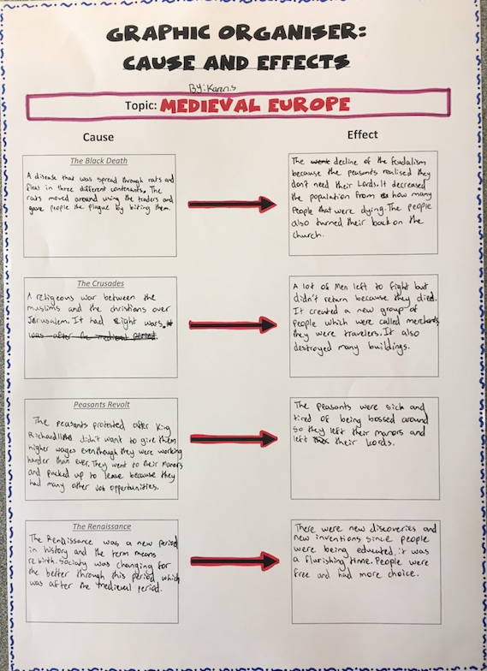

Figure 5: Student work sample of the Cause and Effect graphic organiser- by Karin

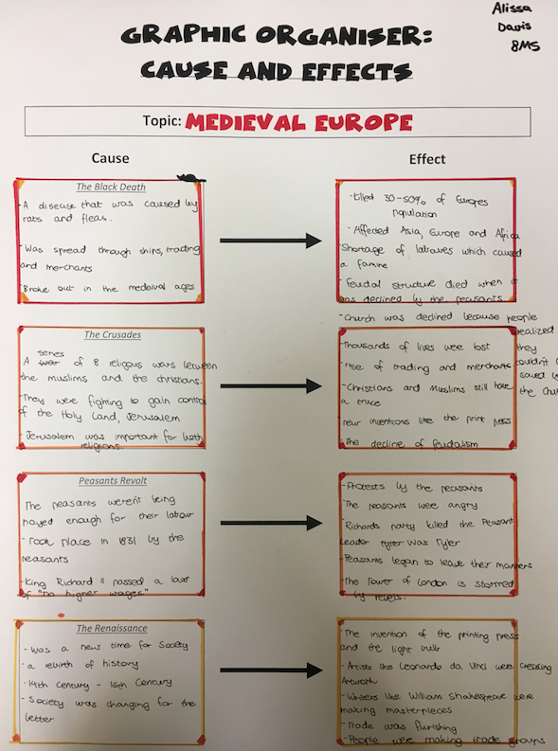

Figure 6: Another work sample of the Cause and Effect graphic organiser- by Alissa

