Article Title:
Implementing a Biblical Vision for Education: Challenges Facing Primary Department Leaders in Christian Schools in Sydney, Australia

Name / Address / Phone:
Beth Boland
29 Wyong Street
Oatley 2223
+61 (0)487 007 131
New Hope International (Regional Coordinator – Indonesia)
Currently on Maternity leave
This research was conducted as a part of the M.Education (Leadership) at Morling College (graduated in March 2021)

Autobiographical Info:
I have been working in Christian education for 15 years, in various Christian schools around Sydney and with IPEKA Integrated Christian School, in Jakarta, Indonesia. I am passionate about supporting teachers develop curriculum from a biblical foundation and implement it through biblical best practice approaches. I assist with the work of New Hope International (NHI) in various roles including teacher training and editing and developing curriculum that better equips teachers and school leaders to understand and practice God’s truths about education. Currently I invest most of my time loving on my sweet three-year-old daughter and 6-month-old son.

Key words: vision, Christian school, leaders, challenges

Article Title:
Implementing a Biblical Vision for Education: Challenges Facing Primary Department Leaders in Christian Schools in Sydney, Australia

Key words: vision, Christian school, leaders, challenges

Abstract:
This article outlines the results of a recent study that investigated the challenges primary department leaders in Christian schools in Sydney are faced with as they seek to implement a biblical vision for education, along with strategies used to overcome the challenges.
Competing Priorities was found to be the central challenge facing Christian school leaders as they seek to implement a biblical vision for education. Others identified include: Governance Issues, Changed Parent Expectations, Commodification of Education, Dealing with Conflicts and Human Resource Management Issues.
With consideration of the challenges faced by Christian school leaders, the paper highlights a number of key strategies found in the study. These could be critically effective in assisting educators to help overcome the current problem facing Christian schools, that their ideologies are being challenged due to a rise in secularism in Australia, and assist them as they implement a biblical vision for education in their school. The results were displayed diagrammatically.

Introduction
Research reporting the rise of secularism in Australian schools (Campbell, Proctor and Sherrington, 2009) suggests that Australian Christian schools are functioning during a time of great tension. Christian school leaders in Australia face challenges in implementing a biblical vision for education. Their founding ideologies are being challenged and their practices coerced to conform to a vision opposed, in many ways, to the biblical vision of education from which they were formed. With the rise of a secular vision for education and the indication that Christian schools are not always realising their biblical vision for education, it is vital that the challenges facing Christian school leaders in implementing their biblical vision for education are investigated. Identifying challenges provides an opportunity for problems to be addressed (Gibbs, 2012).
This study sought to answer the following questions:
- What are the challenges primary department leaders face as they seek to implement a biblical vision for education?
- How do primary department leaders seek to overcome these challenges in Christian schools in Sydney?

A school’s vision is their compass. It directs their journey and determines their destination. Vision produces focus, ensures the main thing remains as the main thing, and can smooth leadership successions (Harris, 2013). A clear biblical vision can assist the Christian school leader to fulfil God’s purposes and ensures that faith-based organisations do not drift from their course (Greer and Horst, 2014). For the purposes of this study, vision was defined as ‘a mindset and or set of beliefs that directs the journey and determines the destination that a school is aiming to reach’.
Christian schools will eminate God’s truth in their practice if the vision they are seeking to implement is a biblical one. Many Christian educators believe that the Bible, and particularly the Gospel message, will be at the heart of a true Christian school (Frisken, 2013; Goheen, 2004; Roy, 2008; Thompson, 2004). Biblical vision in a Christian school is not just a written statement to do with God’s kingdom, but is to include the outworking of the Gospel within the school. The key component to implementing a biblical vision for education is the Christian school leader being like Christ.

Challenges Found in the Literature
In the current culture of rapid change (Duignan, 2012), where religious values are considered less important in Australian society compared to the past (Neidhart, 2014), Christian schools are faced with challenges that interfere with the implementation of a biblical vision. These can undermine the key values and founding principles by which Christian schools began.
The digital technological revolution, coupled with globalisation, is a challenge facing Christian school leaders since it calls upon investment of time and resources. In 2008 the Australian federal government, under Rudd’s leadership, introduced a ‘Digital Education Revolution’, encouraging schools to be using and teaching with up to date digital technologies. As digital technology is rapidly developing, it has been difficult for schools to keep up. Burnett and Turner (2018) explained that technologies are exponentially expanding and will impact leaders in education more than they have previously.
There are increasing expectations on improving the quality of education globally, challenging the Christian school leader to consider their priorities. Tuinamuana (2011) identified that Australian Christian school leaders are influenced by the global drive towards professional standards and accountability in education. Leaders in schools have less time to lead teaching and learning due to the push to meet accountability expectations (Edwards, 2014a). Along with this, market competition is pushing schools towards corporatization (Edwards, 2014a) and professionalization of education has become important.
In Australia the concept of ‘educational excellence’, which is a prevalent term used in education now (Justins, 2009), has been challenging Christian schools to consider their priorities. This terminology carries with it the implication of competitiveness and high academic achievement, being driven by consumerist and individualistic ideologies.
Teachers in Christian schools need to be able “…to integrate their faith with their teaching so that they teach from a Christian worldview ” (Harvey, 2009, p. 6). This may be a particular challenge since it has been found that most teachers in Christian schools have been taught in institutions where “…God is seen as an intrusion” (Fyson, 2014a, p. 3).
The development of a school community aligned to a biblical vision for education is another challenge for the Christian school leader. Johnston (2008) highlights obstacles to building community, particularly attributed to disconnectedness and individualism. In Western civilization, the exaltation of individualism, which minimises community, has caused people to have less respect for one another and other moral virtues and the loss of a spiritual dimension to life (Johnston, 2008).

Methodology
An exploratory qualitative case study approach was taken to investigate the challenges facing Christian school leaders as they seek to implement a biblical vision for education. The researcher sought to provide an in-depth understanding of the issue, which was explored at four school sites in Sydney, Australia, making it a multi-site case study. Grounded theory methodology (GTM) (Glaser and Strauss, 1967; Strauss and Corbin, 1990, 1998) with coding strategies as outlined by Strauss and Corbin (1990, 1998) and Charmaz (2006, 2014), were used in this project to analyse data and generate the theory.
The researcher’s belief about knowledge creation is best aligned with Smith (2011), who explains “our theories…are developed…by employing our best persona, substantive knowledge as participants in reality about how reality operates” (p. 294). The researcher also considers Colossians 2:3, which explains that in Christ all the treasures of wisdom and knowledge are found.
A purposive sampling technique was used which allowed data to be collected from participants in various leadership roles in Christian schools within a 40km radius of the city of Sydney, Australia. The leaders were working in schools that were a part of the most recent Christian school movement that started in the 1970s, and used to be or are still a part of Christian Schools Australia or Christian Education National.
The main research instrument was the interview proforma, which included several background information questions and six interview questions. The interview questions were general and open-ended, written specifically to prompt the participants to share about implementing a biblical vision for education. An interview protocol was developed to ensure a consistent interview approach was followed. Data was collected from eight participants (two per school site) via a semi-structured face-to-face interview. The researcher sought to gain accuracy of field notes by member checking.

Results and Discussion
How Leaders Defined and Seek to Implement a Biblical Vision
Leaders articulated the main elements of a biblical vision for education to include beliefs formed from a Christian worldview, actions guided by what the Bible says about living for Christ and that the main goal of a biblical vision for education be that children learn to live for Christ. These ideas are similar to those outlined by Christian educators, such as Van Brummelen (2009), who relate a biblical vision to preparing students to be and become citizens of God’s kingdom.
It was also found that every leader believed implementing a biblical vision was of high importance, with many explaining that an intentional attitude was needed at every leadership level within the school in order to effectively implement the vision. Each leader identified several approaches they take to implementing a biblical vision, including living out the vision, enabling staff through avenues such as professional development, implementing intentional co-curricular activities and having empathy with school community members, especially staff. Many leaders suggested that the vision be ‘embodied’.
For a leader to truly model the way for their staff they must first ‘lead’ themselves (Maxwell, 2004). It became clear that each leader sought to do this, keeping the Bible, and particularly the gospel message, at the heart of their school in all they do. The leaders were seeking to be like Christ.

Challenges Identified by Leaders as they Implement a Biblical Vision for Education
Leaders identified several challenges they face as they seek to implement a biblical vision. These challenges were categorized through coding of responses given during the interviews. The following categories emerged: Governance Issues, Changed Parent Expectations, Commodification of Education, Human Resource Management Issues, Dealing with Conflicts and Competing Priorities. A diagram representating the relationships between the six categories of challenges identified about implementation of a biblical vision is shown in Figure 1.

INSERT FIGURE ONE HERE (Appendix 1)

The central challenge to implementing a biblical vision for education was Competing Priorities, to which all the other categories contribute, represented by dashed line arrows. Three of these categories could be seen as influencers: Changed Parent Expectations, Commodification of Education and Human Resource Management (HRM) Issues, represented by solid lined arrows. These three challenges influenced Dealing with Conflict and Governance Issues. Following are descriptions about these challenges.

Competing Priorities
The leaders were trying to balance too many things, felt pressure from society, and were overloaded, explaining there were too many ideas from the ‘top’. They found that time to reflect on and communicate the school vision were a challenge. Leaders expressed a general feeling of being overwhelmed by responsibility. It could be said that they faced the many competing voices demanding the attention of the school leader, as outlined by Pietsch (2018): “History, policies, research, parental and student concerns, and the theological vision of the school – these are the significant voices that demand the attention of school leaders” (p. 62). Time constraints were extensive, with one leader explaining, “…often your priorities are hijacked.” It was difficult for the leaders to focusing on biblical priorities. For some there was confusion about the nature of Christian schools. This was coupled with worry that Christian schools could not stay afloat. Most leaders expressed concern about their teaching staff being over worked, with some attributing this to high curriculum demands placed on schools.

Governance Issues
This included both external and internal governance issues. External governance issues included curriculum compliance to authorities like the New South Wales Education Standards Authority (NESA) and ensuring that teachers maintained their accreditation, which demanded much time and energy. Tuinamuana (2011) noted that that the Australian Professional Standards for Teachers has intensified the workload and placed more external pressure on schools to comply with regulations and policies. Internal issues included maintenance of the board and school culture to a biblical vision, aligning with Edwards (2014a), who found that Christian school boards are often dominated by secular thinking.

Human Resource Management (HRM) Issues
There were difficulties for some leaders in recruiting suitably qualified Christian staff and provide effective professional development (PD) for them. Edlin (2014) cautioned Christian schools that are not intentional and consistent with PD for their staff, risk marginalising their core reason for existence. Leaders in the study particularly mentioned that enabling staff to incorporate a biblical worldview into the culture of the school along with curriculum was a challenge, as many staff had not considered a biblical approach to education. Fyson (2014a) explained that many teachers in Christian schools have themselves been educated in a godless environment, which has had a major impact on classrooms around the world.

Dealing with Conflicts
Most leaders raised dealing with conflicts as a challenge. Sometimes this was associated with discipline of staff, but more often it was conflicts within the school community: between staff, between staff and parents, between staff and other school community stakeholders or between students. Harris (2013) explained that while people united by a common vision will ideally work well together, this is often not the reality. Denominational differences were highlighted to present a strain on relationships, along with staff gossip. It was suggested by Reel (2015) that weariness can make it harder for the Christian school leader to uphold a biblical vision for discipline and conflict resolution, suggesting leaders may be challenged further when fatigued.

Commodification of Education
Some leaders explained that education was being viewed more as a commodity, or a product that can be traded, compared to a valuable service that is delivered. New technologies have become an avenue by which education is commodified. This directly connects with the challenge of Changed Parent Expectations. Commodification of Education is influenced by the ideologies of consumerism, economic rationalism and individualism, key components of secularism. The ideology that Campbell, Proctor and Sherington, (2009) found schools in Australia to be increasingly aligning to.
Leaders also mentioned of the use of technology to market schools in new and unique ways as a challenge, aligning with Burnett and Turner (2018), who highlighted an exponential expansion of technologies impacting leaders in education more than previously. The intangible nature of key qualities of Christian education were seen to be a challenge to market to parents, with one leader questioning, “We love the kids, but how do you put that on social media?”

Changed Parent Expectations
Leaders were challenged by a different attitude from parents, with comparison made in some instances to parent expectations held in the founding days of Christian schooling. Some felt the partnerships were not as close as they once used to be. Pietsch (2018) recognised, increasingly in these times, there is a disconnect between the purposes of a Christian school and the desires of some parents who send their children to Christian schools. Leaders interviewed believed that some parents did not necessarily share the school’s vision, but rather sent their children to a Christian school for, what one leader described as, “…a good child with a good HSC result”. Since values and educational achievement are two major motivations for parents choosing independent schools (an Australian Institute Survey cited in Edwards, 2014b), parents who may not share the school’s vision may still be attracted to Christian schools, contributing to the misalignment of vision between parents and Christian schools.

Strategies identified by Leaders to Overcome the Challenges
The results related to the strategies used to overcome the challenges of implementing a biblical vision for education were coded into six categories: Building Relationships, Christian Practices, Professional Development (PD), Opportunities for Collaboration, Reflection and Policy or Procedural Changes. These categories and their relationships are represented in Figure 2.

INSERT FIGURE TWO HERE (APPENDIX 2)

Two strategies were described as effective to overcome all challenges identified, Building Relationships and Christian Practices. In the figure these are represented by the boundary that encircles the whole diagram. Other strategies were connected with overcoming specific challenges as seen by use of oval boundary lines.

Building Relationships
Sharing the biblical vision by speaking about it regularly to staff was important to leaders as a way of Building Relationships. Kouzes and Posner (2012) explained that positive communication is highly important to ‘Inspire a Shared Vision’. A vision that is ‘owned’ by many stakeholders in a school…is likely to have a greater influence on all in the school community (Harris, 2013). Leaders considered that clear communication, empathy and advocacy were helpful to overcome challenges, particularly when Dealing with Conflicts and Changed Parent Expectations.
Inviting parents to be partners, as found in this study, is seen by Quaglia (2016) as an effective way for school principals to overcome the challenges to do with parents being disengaged. Listening and advocating for staff were a part of overcoming challenges as well. Two leaders explained that visual displays have also been a helpful communication tool to remind the school community about its biblical vision for education.

Christian Practices
Christian Practices, which involved leaders modelling their relationship with God, were not only seen as fundamental to facing all challenges identified, they were also a motivation and inspiration for leaders to continue leading in their school contexts. Prayer, devotions, trusting that God is in control, submitting to God, praising God, meditating on the Bible and speaking the Word were such strategies.
The concept of the leader being the person that they want others to become aligns to general and Christian leadership ideas. Kouzes and Posner (2012) describe ‘Model the Way’ as one of five practices of exemplary leaders. For a leader to truly ‘Model the Way’ for their staff they must first ‘lead’ themselves (Maxwell, 2004). Gunderson (2006) describes modelling as something that Christian leaders should eat, sleep, breathe and think. Further, Ledbetter, Banks and Greenhalgh (2016) suggest that it would be dangerous for the church and the world if Christian leaders did not follow Jesus, the Son of God.
One participant explained why she sought to be led by the Lord, “we are working for his glory and they are his skills and his gifts and his talents that he has provided us with for that purpose”.

Policy or Precedural Changes
Policy or Procedural changes were mostly referred to as a strategy to overcome Changed Parent Expectations. Schools already had enrolment policies in place to suit their particular context, which would help to set realistic parental expectations about the biblical vision of their schools. This included parents signing agreements at enrolment about the school’s biblical teachings. These policy and procedural changes may allow for a context to be created whereby school community members could implement the school’s vision, as was suggested by Van Brummelen (2009) to be the key reason why school policies exist. Collins and Porras (2004) similarly explain that the core ideology of a school can be preserved through organisation and strategic alignment, which can be seen in a school’s policies and procedures.
One participant shared about a uniform variation policy developed that was associated with religious beliefs outside of the Christian faith. There was also mention of recruitment policies that allowed for better screening of applicants.

Reflection
Self-reflection by leaders and providing opportunities for staff to reflect, not only helped leaders to overcome competing priorities, but allowed leaders to more effectively live out the vision. This aligns with Whitaker (1995), and Osterman and Kottkamp (2004), who identified reflection as an essential practice by educational leaders.
Combined with prayer and meditation, reflection was considered a particularly helpful strategy when leaders were dealing with conflicts and HRM Issues. Atkin (as cited in Pietsch, 2018) suggests there are benefits when school leaders take time to reflect upon fulfilling government requirements while still maintaining practices consistent with their attitudes, values and beliefs about learning.

Opportunities for Collaboration
Facilitating Opportunities for Collaboration between leaders and teachers was a key strategy to overcoming HRM Issues, particularly in relation to dealing with staff management and being able to professionally develop teachers who do not understand how to design curriculum with a biblical framework. Leaders suggested meetings that enabled the sharing of materials and resources, and a PD framework that allowed for collaboration. Glantz (2006) highlighted the importance of PD being a collaborative task. In addition, schools that perform best tend to extend decision-making and responsibilities to their community (Leithwood and Jantzi, 2012).
Leaders suggested that asking for advice from outsiders as well as those within the school for feedback were opportunites for collaboration that assisted with Governance challenges and HRM Issues. Engaging consultants to assist with particular problems was another strategy mentioned. Leadership mentors were important to some leaders, both from within or outside of their schools. Hallam et al. (2010) research found that advice seeking and learning were forms of collaboration that head teachers used to overcome challenges.

Professional Development
Most leaders mentioned Professional Development (PD) about biblical concepts and how to incorporate a biblical perspective into the curriculum as a strategy that helped to overcome the challenge of staff not being equipped. This aligns to Edlin (2014), who noted PD as a key strategy to maintain the biblically focused vision within a Christian school. Leaders saw staff development weeks as important opportunities to share and upskil staff about a biblical vision for education. Some leaders floated the idea of a mandated certification course about Christian education, with it being implemented already at one of the schools visited. One on one mentoring of teachers was also seen to be effective, “I sit with teachers and help them write programs” (leader).
Dinham et al. (2018) believed that effective principals realise the importance of equipping teachers to teach in their schools, which was the case for the leaders in this study. Further, Edlin (2014) explained that teachers and school administrators are “primarily responsible for implementing the school’s vision for education in the classroom…and will determine the success or failure of the vision’s implementation” (p. 114).

Conclusion
The study sought to address a problem facing Christian school leaders in Australia, that is, the ideologies of Christian schools are being challenged and leader’s practices may conform to a vision that is opposed, in many ways, to a biblical vision for education. This problem appears, in some ways, to relate to the rise of secularism in Australian schools. Christian school leaders face several and varied challenges as they seek to implement a biblical vision for education while they lead. Two questions that were the focus of this study are ‘‘What are the challenges primary department leaders face as they seek to implement a biblical vision for education?’ and ‘How do primary department leaders seek to overcome these challenges in Christian schools in Sydney?’
Figures 3 and 4 were developed in direct response to these questions, providing answers in a succinct visual form. They represent the challenges primary department leaders face and strategies used by leaders as they seek to overcome these challenges. Icons have been used to represent each challenge and strategy.
In Figure 3, which visually displays the challenges, the core category, Competing Priorities, includes an icon of a person’s profile in the centre. The person in the centre represents the Christian school leader. The arrows indicate that each other challenge contributes to the Christian school leader being overwhelmed by Competing Priorities.

INSERT FIGURE 3 HERE (APPENDIX 3)

In Figure 4, which visually displays strategies implemented to overcome the challenges, the Christian school leader has a changed persona and surrounding him or her are the strategies used to overcome challenges identified. The strategies connected to particular challenges are overlaid on the challenges they connect to, with Building Relationships and Christian Practices surrounding all the challenges since they were identified as being used to overcome all challenges. The arrows indicate that each strategy contributes to the person in the centre overcoming the challenges.

INSERT FIGURE 4 HERE (APPENDIX 4)

Recommendations
The dissemination of information from this study to Christian school leaders may be a source of encouragement and motivation for them to continue in their role. In particular, sharing the importance of Building Relationships with members of their school community and colleagues in their team, exercising clear communication and having empathy and advocating for them when needed. Along with this, implementing Christian Practices, individually and with their team, such as prayer, devotions, the reading of the Bible and reminding their school community that the Bible teaches that God is in control are also strategies that can be highlighted to leaders.
It is recommended that Christian PD organisations provide training for leaders in Christian schools that address the challenges leaders may face as outlined above and suggested strategies for leaders to overcome these challenges. Sessions in relation to curriculum design and programming may be particularly valid, since there appears to be a great need for this within the four Christian schools in this study, which could be symptomatic of other Christian schools. When conducting training for leaders and teachers in Christian schools, trainers should consider the mode of delivery to include opportunities for collaboration, Christian practices and time for reflection.
In courses designed for Christian school leaders in tertiary institutes, it is recommended they ensure time is allocated for learning about the challenges leaders may face as they seek to implement a biblical vision for education and strategies that can be used to overcome these challenges.
Relevant future studies could include a longitudinal study of leaders in Christian schools, both new and experienced, from primary and high school departments, identifying challenges unique to different levels and stages of leadership, times of the year and locations of Sydney. They could also narrow in on the challenges the COVID-19 pandemic has brought upon Christian school leaders and the way leaders have dealt with them.
It is clear from this study that primary department leaders face several and varied challenges as they seek to implement a biblical vision for education while they lead. Leaders overcome these challenges using various strategies that, if shared with the broader Christian school community, will enable them to be better aware of ways they could overcome these challenges. Gibbs (2012) reminds Christians in ministry it is important that they draw close to each other, working in unity to overcome challenges.

References
Burnett, N. and Turner, D. (2018). Leadership in a time of exponential change. Australian Educational Leader, 40(3), 52-55.

Campbell, C., Proctor, H., & Sherington, G. (2009). School Choice: How parents negotiate the new school market in Australia. Australia: Allen and Unwin.

Charmaz, K. (2006). Constructing Grounded Theory. Los Angeles, CA: SAGE.

Charmaz, K. (2014). Constructing Grounded Theory (2nd ed.). Los Angeles, CA: SAGE.

Collins, J. C., & Porras, J. I. (2004). Built to last: Successful habits of visionary companies. London, United Kingdom: Random House.

Dinham, S., Elliott, K., Rennie, L. & Stokes, H. (2018). I’m the principal: Principal learning, action, influence and identity. Camberwell, VIC: ACER Press.

Duignan, P. (2012). Educational leadership: Together creating ethical learning environments (2nd ed.). Melbourne, Australia: Cambridge University Press.

Edlin, R. (2014). The cause of Christian education (4th ed.). Sioux Center, Iowa: Dordt College Press.

Edwards, R. (2014a). Leadership. In K. Goodlet and J. Collier (Eds.), Teaching well: Insights for educators in Christian schools (pp. 235-245). Canberra, Australia: Barton Books.

Edwards, R. (2014b). Challenge and choice: Australian Anglican schools today. Canberra, Australia: Barton Books.

Frisken, R. (Ed.). (2013). Effective teaching and learning series: Book one introduction to effective teaching and learning. Sydney: New Hope International.

Fyson, S. J. (2014a). Serving God in the Classroom. Sydney, Australia: Resolve Consulting Group Pty. Ltd.

Gibbs, E. (2012). The journey of ministry: Insights from a life of practice. Downers Grove, IL: Intervarsity Press.

Glanz, J. (2006). What every principal should know about instructional leadership. Heatherton, VIC: Hawker Brownlow Education.

Glaser, B. G., & Strauss, A. L. (1967) The discovery of grounded theory: strategies for qualitative research. Chicago, IL: Aldine.

Goheen, M. (2004). The gospel and the idolatrous power of secular science. In J. Ireland, R. J. Edlin, & K. Dickens (Eds.), Pointing the way: Directions for Christian education in a new millennium (pp. 33–54). Blacktown, NSW: National Institute for Christian Education.

Greer, P., & Horst, C. (2014). Mission Drift: The unspoken crisis facing leaders, charities and churches. Bloomington, MI: Bethany House Publishers.

Gunderson, D. (2006). The leadership paradox: A challenge to servant leadership in a power-hungry world. Seattle, WA: YWAM Publishing.

Hallam, P. R., Hite, J. M., Hite, S. J., & Mugimu, C. B. (2010). So you want to be a headteacher?: “Liabilities of newness,” Challenges, and strategies of new headteachers in Uganda. In A. Shoho, B. Barnett, & A. Tooms (Eds.). The challenges for new principals in the twenty-first century (pp. 77-100). Charlotte, NC: Information Age Publishing, Inc.

Harris, B. (2013). The tortoise usually wins: Biblical reflections on quiet leadership for reluctant leaders. UK, Milton Keynes: Paternoster.

Harvey, P. (2009). Motivations of teachers in Christian schools to engage in postgraduate study. (unpublished thesis). University of Western Sydney, Sydney, Australia.

Johnston, G. (2008). Old testament community and spiritual formation. In P. Pettit (Ed.), Foundations of Spiritual Formation: A community approach to becoming like Christ (pp. 71-101). Grand Rapids, MI: Kregel Publications.

Justins, C. (2009). Christian schooling and educational excellence: an Australian perspective. Journal of Education and Christian Belief. 13(1), 49-64.

Kouzes, J. M., & Posner, B. Z. (2012). The leadership Challenge: How to make extraordinary things happen in organizations (5th ed.). San Francisco, CA: Jossey-Bass Publishers.

Ledbetter, B. M., Banks, R. J., & Greenhalgh, D. C. (2016). Reviewing leadership: A Christian evaluation of current approaches. Grand Rapids, MI: Baker Academic.

Leithwood, K., & Janzi, D. (2012). Collective leadership. The reality of leadership within the school community. In K. Leithwood & K. Seashore Louis (Eds.), Linking leadership to student learning. (1st ed., pp. 11 – 24). San Francisco, CA: Jossey-Bass.

Maxwell, J. C. (2004). Reflections on model the way. In B.Z. Posner, & J.M. Kouzes, Christian reflections on the leadership challenge (pp. 41-52). San Francisco, CA: Jossey-Bass.

Neidhart, H. (2014). The faith leadership role of the principal: What the research suggests. In K. Engebretson (Ed.), Catholic Schools and the Future of the Church (pp. 143-161). New York, NY: Bloomsbury Academic.

Osterman, K., & Kottkamp, R. (2004). Reflective practice for educators: Improving schooling through professional development (2nd ed.). Thousand Oaks, CA: Corwin.

Pietsch, J. (2018). Character reborn: A philosophy of Christian education. Sydney, Australia: Acorn Press.

Quaglia, R. J. (2016). Principal Voice: Listen, learn, lead. Thousand Oaks, CA: Corwin.
Reel, S. G. (2015). Clear focus: Rediscovering the most important aspect of Christian school ministry. Bloomington, IN: WestBow Press.

Roy, D. (2008). Christian schools—a world of difference. Teach 2(1), 38-44.

Smith, C. (2011). What is a Person: Rethinking humanity, social life and the moral good from the person up. Chicago, IL: Chicago University Press.

Strauss, A., & Corbin, J. (1990). Basics of qualitative research: Grounded theory procedures and techniques. Newbury Park, CA: SAGE.
Strauss, A., & Corbin, J. (1998). Basics of qualitative research: Grounded theory procedures and techniques (2nd ed.). Newbury Park, CA: SAGE.
Thompson, R. (2004). Genesis and Jesus… and Christian worldview. In J. Ireland, R. Edlin & K. Dickens (Eds.), Pointing the way: directions for Christian education in a new millennium (pp. 155-174). Blacktown, NSW: National Institute for Christian Education.

Tuinamuana, K. (2011). Teacher professional standards, accountability, and ideology: alternative discourses. Journal of Teacher Education, 36(12), 72-82. Retrieved from http://dx.doi.org/10.14221/ajte.2011v36n12.8

Van Brummelen, H. (2009). Walking with God in the classroom: Christian approaches to teaching and learning (3rd ed.). Colorado Springs, CO: Purposeful Design Publications.

Whitaker, K. S. (1995). Principal burnout: Implications for professional development. Journal of Personnel Evaluation in Education, 9, 289-296.

Appendices
Appendix 1

Figure 1 Challenges facing primary department leaders as they seek to implement a biblical vision in Christian schools in Sydney
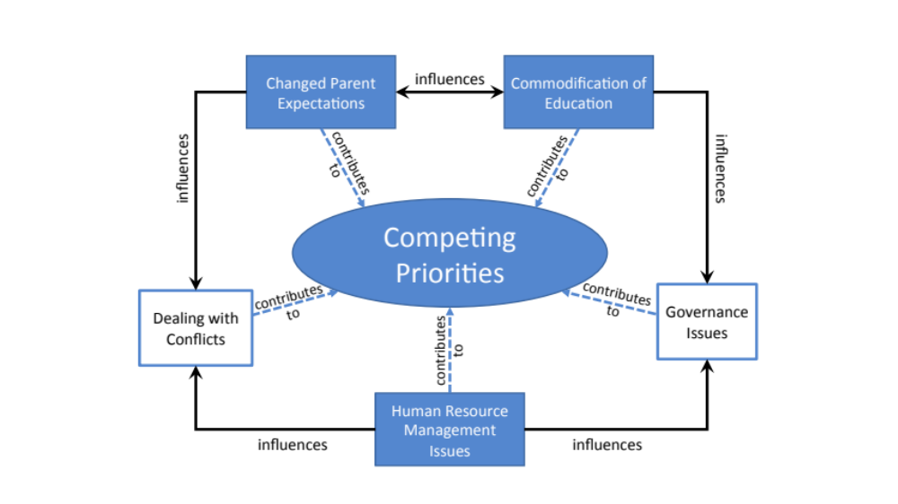

Appendix 2

Figure 2 Strategies to overcome challenges primary department leaders face as they seek to implement a biblical vision for education in Christian schools in Sydney
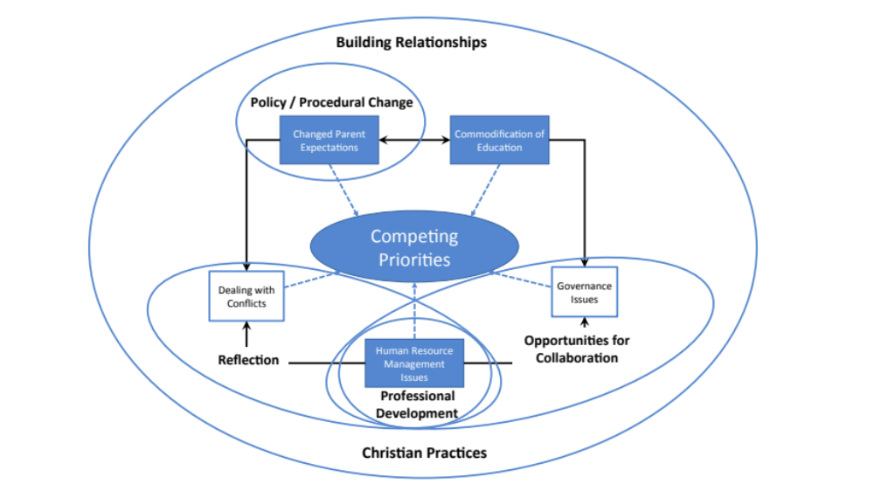

Appendix 3

Figure 3 The Overwhelmed Christian School Leader

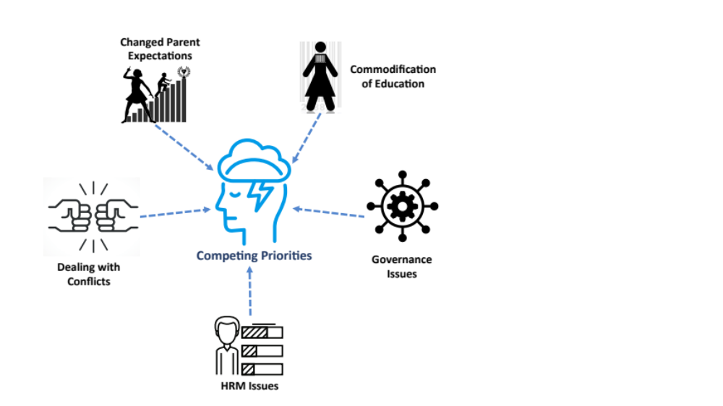

Appendix 4

Figure 4 The Strategic Christian School Leader
