Title
Factors predicting alcohol consumption in adolescents attending a faith-based school system in Australia: A multi-group structural equation analysis.

Abstract
Structural equation modelling was used to explore the direct and indirect association of childhood experiences, attitudes, subjective norms and intentions on the alcohol consumption of adolescents attending faith-based Seventh-day Adventist schools in Australia. Data were collected on 1266 adolescents and the structural model developed explained 48% of the variance for alcohol consumption. Intentions had the highest degree of association with Alcohol Consumption Status (ACS) (β = 0.52). Attitudes were more strongly associated to ACS (β_{total} = 0.36) than subjective norms (β_{total} = 0.17). Adverse Childhood Experiences (ACEs) were associated with every variable in the model and had a combined direct and indirect association with ACS of β_{total} = 0.14. Multi-group analysis found significant pathway differences in the model for gender and age with regards to the association of intentions, attitudes, ACEs and Childhood Family Dynamics with alcohol consumption status. The study fills a gap in the alcohol literature by presenting a model describing the complex network of factors that predict alcohol consumption in a low ACS population. The outcomes of the study highlight the importance of early intervention for children and their families to delay or minimize alcohol consumption in adolescents.

Key Words
adolescent alcohol consumption, childhood family dynamics, attitudes towards alcohol, underage drinking, adverse childhood experiences.

Introduction
The consumption of alcohol by adolescents is an issue of major public health concern globally as it is associated with an array of poor physical, psychological and behavioural outcomes (Gore et al., 2011; National Health and Medical Research Council, 2009). Adolescent alcohol consumption is a leading cause of premature death and injury in adolescents (Gore et al., 2011) and is a key risk factor for early sexual debut (Coleman & Cater, 2005), depression (Fergusson, Boden, & Horwood, 2009) compromised brain function and development (Jacobus & Tapert, 2013; McQueeny et al., 2009), poor academic outcomes (Koch & McGeary, 2005), alcohol dependence (McCambridge, McAlaney, & Rowe, 2011) and adverse mental and physical health in adulthood (Andréasson, Romelsjö, & Allebeck, 1991).
Over the past few decades, there has been a steady decline in alcohol consumption in adolescent populations in many countries including England, the United States (Looze et al., 2015), Australia (Livingston, 2014) and a number of European countries (Looze et al., 2015). In Australia, these declines have occurred across a wide range of population subgroups defined by demographic, geographic and socio-economic factors (Livingston, 2014). Little attempt has been made to explore the factors driving the reduction in alcohol consumption in adolescent populations (Livingston, 2015; Pennay, Livingston, & MacLean, 2015) despite the potential public health benefits (Livingston, 2014).
Factors driving drinking behaviours in adolescents are wide-ranging, occurring on multiple levels. Behaviour change theories such as the Theory of Reasoned Action (TRA) (Ajzen & Fishbein, 1980) have been used extensively to predict, explain and understand health-related behaviours such as alcohol consumption in adolescents (Laflin et al., 1994; Lorenzo-Blanco et al., 2016; Stoddard & Pierce, 2018). The TRA’s premises are threefold. Firstly, the TRA proposes that intentions are an important predictor of behaviour. Secondly, intentions are directly determined by two motivational factors, namely: attitudes and subjective norms. Attitudes refer to the evaluation of a particular behaviour by the individual. Subjective norms capture social pressures that may influence an individual’s intention to use alcohol (Ajzen & Fishbein, 1980). The literature on alcohol use suggests that attitudes towards alcohol use, normative influences and intention to use alcohol are important predictors of adolescent alcohol consumption (Marcoux & Shope, 1997). Thirdly, antecedent to attitudes and subjective norms are beliefs. Fishbein and Ajzen (Fishbein & Ajzen, 2011) regard these beliefs as the psychological determinants that need to be altered to bring about behaviour change.
While numerous theories explain the development of beliefs, Bronfenbrenner’s (Bronfenbrenner, 2005) Bioecological Systems Theory (BST) suggests that the environment in which a child grows, particularly the family environment contributes to a child’s developing beliefs and ultimately their behaviour. Many studies (Kelly et al., 2011; Laghi, Baiocco, Lonigro, Capacchione, & Baumgartner, 2012; Yap, Cheong, Zaravinos-Tsakos, Lubman, & Jorm, 2017) confirm that an adolescent’s family dynamics, including relationship quality, may predict adolescent drinking beliefs, however little research has investigated the relationship between early childhood family dynamics and ACS later in the adolescent years. Other childhood experiences that may influence the development of beliefs are Adverse Childhood Experiences (ACEs) (Felitti et al., 1998). ACEs refer to stressful or traumatic experiences that a child may encounter in early life such as physical, psychological and sexual abuse, neglect, and family dysfunction. These traumatic, stressful experiences have been established as factors that predict alcohol consumption in adolescents (Dube et al., 2006; Felitti et al., 1998; Gonçalves et al., 2016). Studies that have applied the TRA to alcohol consumption have largely overlooked the influence of important antecedent beliefs (Pabian & Vandebosch, 2014). This study attempts to address this gap in the literature by including both the TRA and antecedent beliefs measured through the influence of ACEs and CFD when exploration of predictors of ACS are assessed.
One population of interest is the faith-based Seventh-day Adventist (Adventist) population which has been the subject of extensive health research. Adventists tend to consume significantly lower rates of alcohol than the general population (Orlich et al., 2013a). Indeed the Adventist faith proscribes alcohol consumption and advocates positive family dynamics (Ministerial Association of Seventh-Day Adventists, 1988). A previous study on Adventist adolescents suggested that the Adventist faith influenced the impact family dynamics have on adolescent attitudes towards alcohol consumption and alcohol consumption status. In the study, adolescents with no Adventist parents compared to one Adventist parent, or both parents who were Adventist had increasingly negative attitudes towards alcohol consumption and lower rates of consuming alcohol (Gane, 2012).
The present study employed Structural Equation Modelling (SEM) and applied the TRA and the antecedent childhood experiences ACEs and CFD to examine the direct and indirect association of alcohol consumption operationalized as Alcohol Consumption Status (ACS) among adolescents attending a faith-based school system in Australia. In addition, multi-group SEM analyses were used to more extensively explore gender and age variations in these relationships.

Methods

Study Participants
In 2012 a survey was administered in 21 private Adventist secondary schools across Australia which cater for both Adventist and non-Adventist students. A total of 4674 students attended Adventist secondary schools (years 7–12) in 2012. Completed responses were received from 1266 students (27%) in years seven to twelve. Participation in the study was voluntary and anonymous, and written consent was collected from the students as well as their parents or guardians. The study was approved by the Avondale College of Higher Education Human Research Ethics Committee (No:2011:21). Approximately 41% of adolescents in Australia attended private secondary schools at the time of the survey with 0.9% attending the Adventist school system (ABS, 2017).

Survey Instrument
The survey instrument recorded the participant’s ACS as well as: intentions to consume alcohol, attitudes towards alcohol consumption, subjective norms, CFD, ACEs, and personal demographics.

Alcohol Consumption
Current ACS was measured using an item used in previous Australian adolescent studies (Bowden et al., 2017a; White & Bariola, 2012; White, Hill, & Segan, 1997) that asked: “At the present time, do you consider yourself: 1. Non-drinker. 2. Occasional Drinker. 3. Light Drinker. 4. Party Drinker. 5. Heavy Drinker.” For the purpose of this study, this item was trichotomized to Non-Drink (response 1), Light Drinker (responses 2 and 3) and Heavy Drinker (responses 4 and 5). The authors acknowledge the absence of quantification of this measure, however differences in gender and age using this measure in the above studies are in line with other studies (AIHW, 2014; Livingston, 2014) measuring alcohol consumption with quantifiable measures.

Intentions to Consume Alcohol
Intention to consume alcohol was measured with the single item asking the participants to respond to the statement “I plan to drink alcohol at my current age” with a choice of five options ranging from “Strongly Disagree” to “Strongly Agree”.

Attitudes towards Alcohol Consumption
Attitudes towards alcohol consumption where measured by asking participants to respond to the following statements: “It is ok to drink alcohol at my age”, “Alcohol is harmful to my relationships” and “Alcohol is harmful to my health” with a choice of five options for each statement ranging from “Strongly Disagree” to “Strongly Agree”. The attitudinal items were not combined into a scale so that the individual relationship of each item with ACS could be examined as previously assessed elsewhere (Marcoux & Shope, 1997).

Subjective Norms Surrounding Alcohol Consumption
Subjective norms relating to alcohol consumption were measured using three items. The first item asked respondents: “In the past month would any of your close friends have used alcohol?” with response options “Yes, some of my friends” and “No, none of my friends”. Items two and three used to measure subjective norms asked participants to respond to the following statements: “It is ok for me to say ‘no’ to drinking if friends offer me a drink” and “It is ok for me to say ‘no’ to drinking if family members offer me a drink”. Responses for these items included five options ranging from “Strongly Disagree” to “Strongly Agree”. The subjective norm items were not combined in a scale so that the individual relationship of each normative item with ACS could be examined as previously assessed elsewhere (Marcoux & Shope, 1997).

Childhood Family Dynamics
Childhood family dynamics were assessed by creating a CFD score used in a previous study (Craig, Morton, Morey, et al., 2018) from six items: “As a child, my parents showed me love”; “As a child, my parents understood me”; “While I was a child my family had a lot of fun”; “As a child, my parents didn’t trust me”; “As a child, my parents didn’t care what I did”; and, “As a child, I enjoyed being at home with my family.” Each item included five options ranging from “Strongly disagree” to “Strongly agree.” Each response was given a corresponding value from one to five with higher scores representing increasingly positive outcomes. Responses from each item were summed to calculate an overall CFD score.

Adverse Childhood Experiences
In this study, an adapted ACEs score as described elsewhere (Felitti et al., 1998) and used in a prior study (Craig, Morton, Morey, et al., 2018) was generated by collating the responses from the following nine items: “One or both of my parents were in trouble with the law”; “My parents were separated or divorced”; “One or both my parents died”; “One or both parents were absent from home for long periods”; “There were times when family violence occurred”; “There were times when I was physically abused”; “There were times when I was sexually abused”; “One or both parents smoked tobacco”; and, “One or both parents drank alcohol weekly or more often.” Each item included no/yes response options which were given a corresponding value of zero or one. Responses from each item were summed to calculate an overall ACEs score. It is acknowledged that the item asking about parent’s consumption of weekly alcohol may not equate to an ACE directly, however, may be associated with parental absence or other potential harms.

Religious Affiliation
Religious affiliation was included in this study due to the special nature of the sample. Religious affiliation was assessed by asking the participants: “Which of the following best describes your religious belief now?” Options ranged from: 1. Seventh-day Adventist Christian; 2. Other Christian; 3. Other Religion; 4. No Formal Religion; and 5. Don’t Know. For the purpose of this study, this item was dichotomized to Adventist (response 1) and not Adventist (responses 2-4).

Analysis
The objective of this study was to examine the direct and indirect predictors of alcohol consumption employing SEM. A hypothesized model informed by the literature and the TRA (Ajzen & Fishbein, 1980) is presented in Figure 10 for analysis.
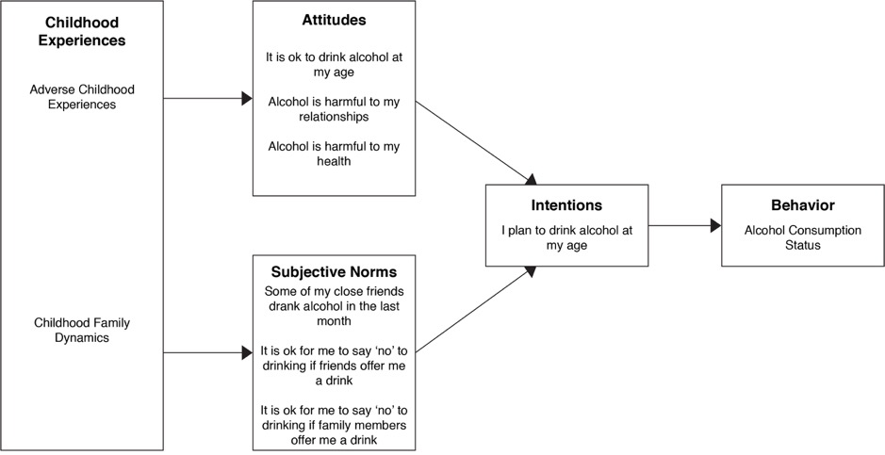
Figure 10. Hypothesised model predicting alcohol consumption status
The most proximal explanatory variables were intentions to consume alcohol followed by attitudes towards alcohol consumption and subjective norms. The distal variables included childhood experiences. The data were imported into SPSS (version 24; IBM, Armonk, NY) to calculate means, standard deviations, distributions and internal reliability. Structural equation modeling using AMOS (Versions 24; Amos Development Corporation, Crawfordville, FL, USA) was conducted to estimate the model fit of the data in the hypothesized model (Figure 1) and simultaneously analyze the direct and indirect effects of the explanatory variables on the outcome variable (Bucy & Holbert, 2014). This was done using techniques developed by Jöreskog and Sörbom (1989) which involved an iterative process of inspection of the statistical significance of path coefficients and theoretical relevance of the constructs in the model to derive an optimal SEM that best fit the dataset and was theoretically meaningful. Overall model fit was examined using multiple goodness-of-fit indices, namely: relative X² (CMIN/DF), baseline comparisons fit indices of normative fit index (NFI), relative fit index (RFI), incremental fit index (IFI), Tucker-Lewis Index (TLI), comparative fit index (CFI), and root mean square error of approximation (RMSEA). A CMIN/DF statistic below three is considered good model fit (Kline, 2010) as are baseline comparisons fit indices above 0.9 (Bentler, 1990). The RMSEA value was less than 0.06, which indicated a close fit between the data and the model (Hu & Bentler, 1999). Bootstrapping (Preacher & Hayes, 2008) was applied to verify the statistical significance of indirect effects at p < .05. Multi-group analysis was employed to test for gender and age variations among the pathways in the study, as age and gender differences have been observed in previous TRA and alcohol consumption studies (Cooke, Dahdah, Norman, & French, 2016). The critical ratios for differences test were applied to assess for regression weight differences in the gender and age groups within the SEM (Ho, 2013).

Results

Descriptive Statistics
A summary of descriptive statistics and reliability estimates is shown in Table 7. Students ages ranged from 12-18 years, mean age 14.6 years, 56% males and 47% of students identified as belonging to the Adventist faith. Eighty-two per cent of the adolescents in the study reported “non-drinker” status, 12% reported “light drinker” status and 6% “heavy drinker” status. Chi-square analysis indicated a significant difference in the proportion adolescents belonging to the ACS categories with less older adolescents (15–18 years) belonging to the non-drinker category and more belonging to the light drinker and heavy drinker categories compared to younger adolescents (12–14 years) (X² = 101.6, p < .01). Further, less non-Adventist students belonged to the non-drinker category and more belonged to the light drinker and heavy drinker category compared to Adventist students (X² = 44.2, p < .01).
Table 7. Descriptive Statistics and Scale Reliability of Variables Used in the Analysis
Variables | N | % | Mean | Standard Deviation | Min | Max | Scale Reliability (α)
Age  Younger Adolescents (12–14 yr olds)  Older Adolescents (15–18 yr olds) | 1266  597  669 | 47.2%  52.8% | 14.64 | ± 1.59 | 12 | 18
Gender  Males  Females | 557  709 | 44%  56%
Adverse childhood experiences score | 1266 |  | 1.39 | ± 1.62 | 0 | 9 | .69
Childhood family dynamics score | 1266 |  | 24.20 | ± 4.73 | 5 | 30 | .84
It is ok to drink alcohol at my age | 1266 |  | 1.92 | ± 1.19 | 1 | 5
Alcohol is harmful to my relationships | 1266 |  | 3.94 | ± 1.26 | 1 | 5
Alcohol is harmful to my health |  |  | 4.25 | ± 1.13 | 1 | 5
Some of my close friends drank alcohol in past month | 1266 |  | 1.52 | ± 0.50 | 1 | 2
It is ok for me to say ‘no’ to drinking if friends offer me a drink | 1266 |  | 4.56 | ± 1.04 | 1 | 5
It is ok for me to say ‘no’ to drinking if family members offer me a drink | 1266 |  | 4.52 | ± 1.07 | 1 | 5
I plan to drink alcohol at my age | 1266 |  | 1.75 | ± 1.20 | 1 | 5
Alcohol Consumption Status | Males |  | Females |  | Younger Adolescents |  | Older Adolescents |  | Total
 | N | % | N | % | N | % | N | % | N | %
A non-drinker  An occasional drinker  A light drinker  A heavy drinker | 460  54  10  33 | 82.6%  9.7%  1.8%  5.9% | 575  75  11  48 | 81.1%  10.6%  1.6%  6.8% | 556  26  8  7 | 93.1%  4.4%  1.3%  1.2% | 479  103  13  74 | 71.6%  15.4%  1.9%  11.1% | 1035  129  21  81 | 81.8%  10.2%  1.7%  6.3%
Abbreviations: α = Cronbach’s alpha

The Model Predicting Alcohol Consumption Status
A final structural model is presented in Figure 11 and describes the associations of childhood experiences (ACES and CFD), attitudes towards alcohol consumption, subjective norms relating to alcohol consumption and intentions to consume alcohol with alcohol consumption status, along with their interactions.
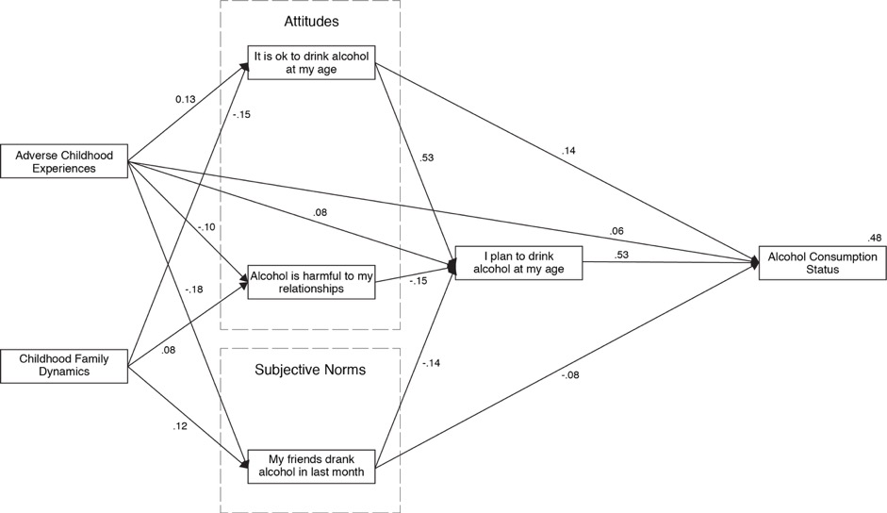
Figure 11. Structural equation model predicting alcohol consumption status in adolescents
The final structural model fitted the data very well, as indicated by the goodness-of-fit indices (CMIN/DF=2.365; NFI=0.997, RFI=0.978; IFI=0.998; TLI=0.987, CFI=0.998 and RMSEA=0.033). The subjective norm items asking: “It is ok for me to say ‘no’ to drinking if friends offer me a drink” and “It is ok for me to say ‘no’ to drinking if family members offer me a drink” were removed from the model due to their non-significant contributions generating the final structural model (Figure 11). Standardized path coefficients are presented as single-headed arrows in the final model. All shown paths are statistically significant including all indirect and combined total pathways. The squared multiple correlation calculated for ACS of 0.48 indicates that the model explained 48% of the variance for alcohol consumption status. The attitudinal variable: “Alcohol is harmful to my health”, and the subjective norm variables “It is ok for me to say ‘no’ to drinking if friends offer me a drink” and “It is ok for me to say ‘no’ to drinking if family members offer me a drink” were removed from the final structural model because of their non-significant contributions to ACS.
The combined direct and indirect association (β_{total}) of the two attitudinal variables (“It is ok to drink alcohol at my age”, “Alcohol is harmful to my relationships”) with ACS was β_{total} = 0.36. This compared with the combined direct and indirect association of the subjective norms variable (“Some of my close friends drank alcohol in the past month”) with ACS which was β_{total} = 0.17. Of the childhood factors measured in the model, the combined direct and indirect association of ACEs with ACS was β_{total} = 0.14 compared to the combined direct and indirect association of CFD with ACS which was β_{total} = -0.10.
Multi-group analysis for gender (Figure 12) found a significant difference in the path coefficient between CFD and “Alcohol is harmful to my relationships” with this association stronger for males (β = 0.15) than for females (β = 0.01). A significant difference in the path coefficient was also found between “It is ok to drink alcohol at my age” and “I plan to drink alcohol at my age” with this association stronger for males (β = 0.58) than for females (β = 0.49).
Multi-group analysis for age groups (12–14yrs versus 15–18yrs) (Figure 12) found a significant difference in three path coefficients. Firstly, the association between ACEs and “Alcohol is harmful to my relationships”, was significantly stronger for older adolescents (β = -0.16) than for younger adolescents (β = -0.03). Secondly, the association between “It is ok to drink alcohol at my age” and “I plan to drink alcohol at my age” was stronger for older adolescents (β = 0.57) than for younger adolescents (β = 0.36). Thirdly, the association between “I plan to drink alcohol at my age” and ACS was stronger for older adolescents (β = 0.51) than for younger adolescents (β = 0.46).
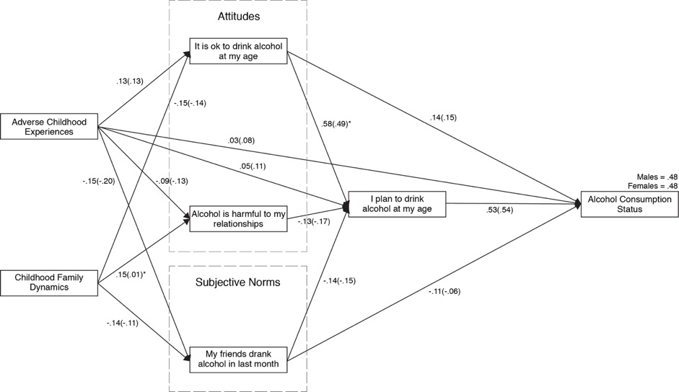
Males(Females); * Significant difference between males and females at p < .05
Figure 12. Structural equation model multi-group analysis for gender

Multi-group analysis for age groups (12–14yrs versus 15–18yrs) (Figure 4) found a significant difference in three path coefficients. Firstly, the association between ACEs and “Alcohol is harmful to my relationships”, was significantly stronger for older adolescents (β = -0.16) than for younger adolescents (β = -0.03). Secondly, the association between “It is ok to drink alcohol at my age” and “I plan to drink alcohol at my age” was stronger for older adolescents (β = 0.57) than for younger adolescents (β = 0.36). Thirdly, the association between “I plan to drink alcohol at my age” and ACS was stronger for older adolescents (β = 0.51) than for younger adolescents (β = 0.46).
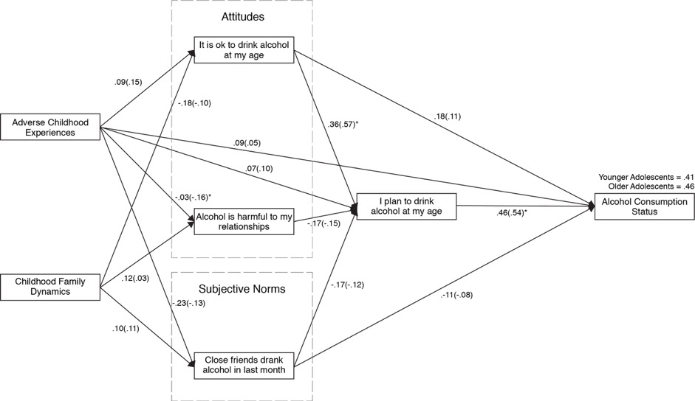
Younger adolescents, 12–14 years (Older adolescents, 15–18 years)
* Significant difference between younger and older adolescents at p < .05
Figure 13. Structural equation model multi-group analysis for age groups

Discussion
This study explored a complex network of factors predicting alcohol consumption status in adolescents attending faith-based schools that promote alcohol abstinence. The study was unique in that it simultaneously measured the association of both negative and positive childhood experiences, current attitudes and subjective norms with intentions to consume alcohol and alcohol consumption status.
Eighty-two per cent of adolescents in this study reported that they were non-drinkers compared to 66% in a 2011 national study (White & Bariola, 2012) and 69% in a South Australian study (Bowden et al., 2017a). These previous studies utilized the same item to measure ACS. The lower rates of alcohol consumption in this study may be due to the high percentage (47%) of adolescents in this study that identify as Adventist. Indeed, more students identifying as Adventist reported belonging to the ACS non-drinker category compared to non-Adventist students. Previous research links religion with lower rates of alcohol consumption in adolescents across multiple measures of religiosity (Sinha, Cnaan, & Gelles, 2007b) however other research has suggested that the protective effect of religion operated more strongly for some religions compared to others (Marsiglia, Kulis, Nieri, & Parsai, 2005). How the Adventist faith may influence predictors of adolescent alcohol consumption is worth further investigation.
The study supports the TRA’s (Ajzen & Fishbein, 1980) ability to enhance understanding of the factors associated with alcohol consumption in adolescents. Intention to consume alcohol had the strongest association with ACS (β = 0.52) which is in line with other TRA and alcohol consumption studies (Cooke et al., 2016). Interestingly, the attitudinal variable “It is ok to drink alcohol at my age” (β = 0.13) and the social norm variable “Some of my close friends drank alcohol in the last month” β = 0.07) was not only associated with intentions to consume alcohol as theorized in the TRA but was also directly associated with ACS (Figure 2).
Examination of the relative importance of the attitudinal and subject norm variables revealed that the combined direct and indirect association of the attitudinal variables (“It is ok to drink alcohol at my age”, and “alcohol is harmful to my relationships”, β_{total} = 0.36) were more predictive of ACS than the subjective norm variable (“In the past month would any of your close friends have used alcohol?”, β_{total} = 0.17). This may be expected considering two subjective norm items were removed from the model during analysis. This result is in line with other studies (Cooke et al., 2016) in adult cohorts, however, TRA and alcohol research (Marcoux & Shope, 1997; Stoddard & Pierce, 2018) in adolescent groups have found that subjective norms were more predictive of adolescent alcohol consumption than attitudes. Wide spread agreement in the literature (Donovan, 2004; Janssen, Mathijssen, van Bon-Martens, van Oers, & Garretsen, 2014; Kuntsche et al., 2015; Ryan, Jorm, & Lubman, 2010) recognizes the powerful influence of social pressures on adolescent drinking behaviours. The lack of importance of subjective norms in the model in this study may be related to overall low prevalence of drinking in this cohort, and in turn, faith. Further study could explore this as a faith-based phenomenon. Minimal research has targeted attitudinal constructs in adolescent cohorts, and this study would suggest that this is worth further investigation.
The non-significant association of the attitudinal variable “Alcohol is harmful to my health” with intention to consume alcohol or ACS was surprising. This adolescent cohort was exposed to a faith-based culture with a long history of emphasizing health and lifestyle education as well as general compliance to the prohibition of alcohol consumption (Craig et al., 2017). The majority of adolescents in a study by Harvey & McKay (2017) did not consider the health consequences of alcohol consumption in their decision making to consume alcohol. While health education is important in any age group, the literature suggests that attitudes towards health in adolescent populations may not be firmly established until later adolescence (Marcoux & Shope, 1997).
Many studies have highlighted the influence of peer and family pressure on adolescent drinking behaviours (Donovan, 2004; Janssen et al., 2014; Kuntsche et al., 2015; Ryan et al., 2010). Accordingly, it was surprising in the present study that two subjective norm items did not significantly predict intentions to consume alcohol or alcohol consumption status. The non-significant association of these subjective norm items may be attributable to the atypical nature of this cohort resulting in lower rates of exposure to alcohol drinking peers and parents. Further investigation into this social phenomenon and its influence on alcohol consumption in adolescents exhibiting low rates of drinking maybe worthwhile.
A key objective of the present study was to simultaneously measure the association of childhood experiences, and the TRA constructs of attitudes, subjective norms, and intentions, on alcohol consumption. Notably, ACEs were associated with every variable in the model, thus further expanding upon the work of others who have reported connection a between ACEs and alcohol consumption in adolescents (Dube et al., 2006). Interventions intended to delay the onset of drinking alcohol in adolescents may be enhanced from understanding the contribution that ACEs have on the lives of children, not only directly, but indirectly through attitudes, social pressures and intentions. As the ACEs score accessed early life experiences, this study highlights the importance gathering information about the early lives of children and their families in order to design preventive strategies targeting ACEs for children and families as early as possible. For adolescents suffering ACEs, advances in neuroeducation based interventions (Leitch, 2017) may enable ACEs affected adolescents to respond in a healthy way to stress caused by ACEs. Although children may have no choice in the ACEs they experience, this study reinforces the necessity for childhood human rights and protection to be at the forefront of global policy and intervention development. Further research examining the mechanism through which ACEs in early childhood contribute to the development of beliefs that drive attitudes and subjective norms would be valuable.
The association of CFD with adolescent alcohol consumption observed in this study is not surprising given that interventions targeting family dynamics have been shown to be the most effective prevention and treatment for adolescent alcohol use (Foxcroft, Ireland, Lister-Sharp, Lowe, & Breen, 2003; Livingston, 2015). Understanding how family dynamics not only influence alcohol use directly but indirectly through attitudes, social pressures and intentions may benefit intervention development. The originating role of family dynamics in early childhood and alcohol consumption later in the adolescent years, points to the potential value of family-based alcohol prevention programs promoting positive family dynamics in early childhood. Comparisons of the CFD experienced by this faith cohort compared to other populations and ACS warrants further investigation.
The multi-group analysis in this study demonstrated several significant pathway differences between gender and adolescent age groups. The stronger association between intention to consume alcohol and alcohol consumption in older adolescents compared to younger adolescents was expected. The attitude that it is ok to drink alcohol had a stronger association with intention to consume alcohol for males and older adolescents which may also explain the higher ACS in older adolescents compared to younger adolescents. Interventions addressing this attitude in males and older adolescents may decrease alcohol consumption in these groups. The gender and age differences in the pathways between ACEs and CFD and the attitudinal variable “alcohol is harmful to my relationships” also highlight the importance of age and gender appropriate intervention development in these areas.

Strengths and Limitations
The strength of this study is that it simultaneously measured the association of the childhood experiences, ACEs and CFD and the key TRA constructs of attitudes, subjective norms, intentions on alcohol consumption. However, it is acknowledged that the model presented in this study, although strong, does not represent all factors that are related to adolescent alcohol consumption. For example, individual characteristics, policy, pricing, advertising and higher densities of alcohol outlets are also associated with ACS (Livingston, 2014). Although the item measuring ACS has been used in previous studies (Bowden et al., 2017a; White & Bariola, 2012; V. M. White et al., 1997), its subjective nature is acknowledged. Future studies may benefit from an alcohol consumption frequency measure in an attempt to gain a more objective measure of alcohol consumption. The cross-sectional nature of this study means that only associations could be measured and hence it is not possible to conclude causality. Futures studies may also benefit from employing the Theory of Planned Behaviour which extends on the TRA by positing that the construct perceived behavioural control also influences intentions and subsequent behaviours.

Conclusion
This study presents a model describing a complex network of factors associated with alcohol consumption in adolescents that exhibit lower rates of drinking than the general population. The results confirm the association of intentions, attitudes towards alcohol consumption, subjective norms surrounding alcohol consumption and childhood experiences with alcohol consumption status. The study fills a gap in the literature relating to factors predicting alcohol consumption in a low ACS population. The findings highlight the importance of designing age and gender appropriate interventions for children and families as early as possible in order to delay or minimize alcohol consumption in adolescents.

References
Ajzen, I., & Fishbein, M. (1980). Understanding Attitudes and Predicting Social Behavior (1 edition). Englewood Cliffs, N.J: Pearson.
Andréasson, S., Romelsjö, A., & Allebeck, P. (1991). Alcohol, social factors and mortality among young men. British Journal of Addiction, 86(7), 877–887. https://doi.org/10.1111/j.1360-0443.1991.tb01843.x
Australian Bureau of Statistics. (2017). Schools Australia 2017. Retrieved from http://www.abs.gov.au/AUSSTATS/abs@.nsf/DetailsPage/4221.02017?OpenDocument
Bentler, P. M. (1990). Comparative fit indexes in structural models. Psychological Bulletin, 107(2), 238–246.
Bowden, J. A., Delfabbro, P., Room, R., Miller, C. L., & Wilson, C. (2017). Prevalence, perceptions and predictors of alcohol consumption and abstinence among South Australian school students: a cross-sectional analysis. BMC Public Health, 17. https://doi.org/10.1186/s12889-017-4475-5
Bronfenbrenner, U. (2005). The bioecological theory of human development. In U. Bronfenbrenner (Ed.), Making human beings human: bioecological perspectives on human development (pp. 3–15). Thousand Oaks, CA: Sage.
Bucy, E. P., & Holbert, R. L. (2014). Sourcebook for Political Communication Research: Methods, Measures, and Analytical Techniques. Routledge.
Coleman, L. M., & Cater, S. M. (2005). A qualitative study of the relationship between alcohol consumption and risky sex in adolescents. Archives of Sexual Behavior, 34(6), 649–661. https://doi.org/10.1007/s10508-005-7917-6
Cooke, R., Dahdah, M., Norman, P., & French, D. P. (2016). How well does the theory of planned behaviour predict alcohol consumption? A systematic review and meta-analysis. Health Psychology Review, 10(2), 148–167. https://doi.org/10.1080/17437199.2014.947547
Craig, B., Morton, D., Kent, L., Butler, T., Rankin, P., & Price, K. (2017). The Body Mass Index of Adolescents Attending Seventh-Day Adventist Schools in Australia: 2001-2012. The Journal of School Health, 87(8), 630–637. https://doi.org/10.1111/josh.12535
Craig, B., Morton, D., Morey, P., Kent, L., Gane, B., Butler, T., … Price, K. (2018). The association between self-rated health and social environments, health behaviors and health outcomes: a structural equation analysis. BMC Public Health, 18, 440. https://doi.org/10.1186/s12889-018-5323-y
Donovan, J. E. (2004). Adolescent alcohol initiation: a review of psychosocial risk factors. The Journal of Adolescent Health: Official Publication of the Society for Adolescent Medicine, 35(6), 529.e7-18. https://doi.org/10.1016/j.jadohealth.2004.02.003
Dube, S. R., Miller, J. W., Brown, D. W., Giles, W. H., Felitti, V. J., Dong, M., & Anda, R. F. (2006). Adverse childhood experiences and the association with ever using alcohol and initiating alcohol use during adolescence. The Journal of Adolescent Health: Official Publication of the Society for Adolescent Medicine, 38(4), 444.e1-10. https://doi.org/10.1016/j.jadohealth.2005.06.006
Felitti, V. J., Anda, R. F., Nordenberg, D., Williamson, D. F., Spitz, A. M., Edwards, V., … Marks, J. S. (1998). Relationship of childhood abuse and household dysfunction to many of the leading causes of death in adults. American Journal of Preventive Medicine, 14(4), 245–258. https://doi.org/10.1016/S0749-3797(98)00017-8
Fergusson, D. M., Boden, J. M., & Horwood, L. J. (2009). Tests of causal links between alcohol abuse or dependence and major depression. Archives of General Psychiatry, 66(3), 260–266. https://doi.org/10.1001/archgenpsychiatry.2008.543
Fishbein, M., & Ajzen, I. (2011). Predicting and Changing Behavior: The Reasoned Action Approach. Taylor & Francis.
Foxcroft, D. R., Ireland, D., Lister-Sharp, D. J., Lowe, G., & Breen, R. (2003). Longer-term primary prevention for alcohol misuse in young people: a systematic review. Addiction (Abingdon, England), 98(4), 397–411.
Gane, B. (2012). Valuegenesis II Study 1 - Core Report. Cooranbong, Australia: Avondale Academic Press.
Gonçalves, H., Soares, A. L. G., Santos, A. P. G. D., Ribeiro, C. G., Bierhals, I. O., Vieira, L. S., … Menezes, A. M. B. (2016). Adverse childhood experiences and consumption of alcohol, tobacco and illicit drugs among adolescents of a Brazilian birth cohort. Cadernos De Saude Publica, 32(10), e00085815. https://doi.org/10.1590/0102-311X00085815
Gore, F. M., Bloem, P. J., Patton, G. C., Ferguson, J., Joseph, V., Coffey, C., … Mathers, C. D. (2011). Global burden of disease in young people aged 10–24 years: a systematic analysis. The Lancet, 377(9783), 2093–2102. https://doi.org/10.1016/S0140-6736(11)60512-6
Harvey, S. A., & McKay, M. T. (2017). Perspectives on adolescent alcohol use and consideration of future consequences: results from a qualitative study. Child Care in Practice, 23(1), 104–120. https://doi.org/10.1080/13575279.2015.1126230
Ho, R. (2013). Handbook of Univariate and Multivariate Data Analysis with IBM SPSS, Second Edition (2 edition). Boca Raton: Chapman and Hall/CRC.
Hu, L., & Bentler, P. M. (1999). Cutoff criteria for fit indexes in covariance structure analysis: Conventional criteria versus new alternatives. Structural Equation Modeling: A Multidisciplinary Journal, 6(1), 1–55. https://doi.org/10.1080/10705519909540118
Jacobus, J., & Tapert, S. F. (2013). Neurotoxic effects of alcohol in adolescence. Annual Review of Clinical Psychology, 9, 703–721. https://doi.org/10.1146/annurev-clinpsy-050212-185610
Janssen, M. M., Mathijssen, J. J., van Bon-Martens, M. J., van Oers, H. A., & Garretsen, H. F. (2014). A qualitative exploration of attitudes towards alcohol, and the role of parents and peers of two alcohol-attitude-based segments of the adolescent population. Substance Abuse Treatment, Prevention, and Policy, 9, 20. https://doi.org/10.1186/1747-597X-9-20
Jöreskog, K. ., & Sörbom, D. (1989). LISREL 8: A Guide to Program and Applications. Chicago: SPSS.
Kelly, A. B., Toumbourou, J. W., O’Flaherty, M., Patton, G. C., Homel, R., Connor, J. P., & Williams, J. (2011). Family relationship quality and early alcohol use: evidence for gender-specific risk processes. Journal of Studies on Alcohol and Drugs, 72(3), 399–407.
Kline, R. B. (2010). Principles and Practice of Structural Equation Modeling, Third Edition (3rd edition). New York: The Guilford Press.
Koch, S. F., & McGeary, K. A. (2005). The Effect of Youth Alcohol Initiation on High School Completion. Economic Inquiry, 43(4), 750–765. https://doi.org/10.1093/ei/cbi052
Kuntsche, E., Wicki, M., Windlin, B., Roberts, C., Gabhainn, S. N., Sluijs, W. van der, … Demetrovics, Z. (2015). Drinking Motives Mediate Cultural Differences but Not Gender Differences in Adolescent Alcohol Use. Journal of Adolescent Health, 56(3), 323–329. https://doi.org/10.1016/j.jadohealth.2014.10.267
Laflin, M. T., Moore-Hirschl, S., Weis, D. L., & Hayes, B. E. (1994). Use of the Theory of Reasoned Action to Predict Drug and Alcohol Use. International Journal of the Addictions, 29(7), 927–940. https://doi.org/10.3109/10826089409047918
Laghi, F., Baiocco, R., Lonigro, A., Capacchione, G., & Baumgartner, E. (2012). Family functioning and binge drinking among Italian adolescents. Journal of Health Psychology, 17(8), 1132–1141. https://doi.org/10.1177/1359105311430005
Leitch, L. (2017). Action steps using ACEs and trauma-informed care: a resilience model. Health & Justice, 5. https://doi.org/10.1186/s40352-017-0050-5
Livingston, M. (2014). Trends in non-drinking among Australian adolescents. Addiction, 109(6), 922–929. https://doi.org/10.1111/add.12524
Livingston, M. (2015). Understanding recent trends in australian alcohol consumption. Canberra: Foundation for Alcohol Research and Education. Retrieved from http://www.fare.org.au/wp-content/uploads/research/Understanding-recent-trends-in-Australian-alcohol-consumption.pdf
Looze, M. de, Raaijmakers, Q., Bogt, T. ter, Bendtsen, P., Farhat, T., Ferreira, M., … Pickett, W. (2015). Decreases in adolescent weekly alcohol use in Europe and North America: evidence from 28 countries from 2002 to 2010. European Journal of Public Health, 25(suppl_2), 69–72. https://doi.org/10.1093/eurpub/ckv031
Lorenzo-Blanco, E. I., Schwartz, S. J., Unger, J. B., Zamboanga, B. L., Rosiers, S. E. D., Baezconde-Garbanati, L., … Pattarroyo, M. (2016). Alcohol use among recent immigrant Latino/a youth: acculturation, gender, and the Theory of Reasoned Action. Ethnicity & Health, 21(6), 609–627. https://doi.org/10.1080/13557858.2016.1179723
Marcoux, B., & Shope, J. (1997). Application of the Theory of Planned Behavior to adolescent use and misuse of alcohol. Health Educ. Res., 12. https://doi.org/10.1093/her/12.3.323
Marsiglia, F. F., Kulis, S., Nieri, T., & Parsai, M. (2005). God Forbid! Substance Use Among Religious and Nonreligious Youth. The American Journal of Orthopsychiatry, 75(4), 585–598. https://doi.org/10.1037/0002-9432.75.4.585
McCambridge, J., McAlaney, J., & Rowe, R. (2011). Adult consequences of late adolescent alcohol consumption: a systematic review of cohort studies. PLoS Medicine, 8(2), e1000413. https://doi.org/10.1371/journal.pmed.1000413
McQueeny, T., Schweinsburg, B. C., Schweinsburg, A. D., Jacobus, J., Bava, S., Frank, L. R., & Tapert, S. F. (2009). Altered white matter integrity in adolescent binge drinkers. Alcoholism, Clinical and Experimental Research, 33(7), 1278–1285. https://doi.org/10.1111/j.1530-0277.2009.00953.x
Ministerial Association of Seventh-Day. (1988). Seventh-day Adventists Believe...A Biblical Exposition of 27 Fundamental Doctrines (First edition). Washington, DC: Review and Herald Publishing Association.
NHMRC. (2009). Australian Guidelines to Reduce Health Risks from Drinking Alcohol. Canberra, Australia: Author. Retrieved from http://www.nhmrc.gov.au/_files_nhmrc/publications/attachments/ds10-alcohol.pdf
Orlich, M. J., Singh, P. N., Sabaté, J., Jaceldo-Siegl, K., Fan, J., Knutsen, S., … Fraser, G. E. (2013). Vegetarian dietary patterns and mortality in Adventist Health Study 2. JAMA Internal Medicine, 173(13), 1230–1238. https://doi.org/10.1001/jamainternmed.2013.6473
Pabian, S., & Vandebosch, H. (2014). Using the theory of planned behaviour to understand cyberbullying: The importance of beliefs for developing interventions. European Journal of Developmental Psychology, 11(4), 463–477. https://doi.org/10.1080/17405629.2013.858626
Pennay, A., Livingston, M., & MacLean, S. (2015). Young people are drinking less: It is time to find out why. Drug and Alcohol Review, 34(2), 115–118. https://doi.org/10.1111/dar.12255
Preacher, K. J., & Hayes, A. F. (2008). Asymptotic and resampling strategies for assessing and comparing indirect effects in multiple mediator models. Behavior Research Methods, 40(3), 879–891.
Ryan, S. M., Jorm, A. F., & Lubman, D. I. (2010). Parenting Factors Associated with Reduced Adolescent Alcohol Use: A Systematic Review of Longitudinal Studies. Australian & New Zealand Journal of Psychiatry, 44(9), 774–783. https://doi.org/10.1080/00048674.2010.501759
Sinha, J. W., Cnaan, R. A., & Gelles, R. J. (2007). Adolescent risk behaviors and religion: Findings from a national study. Journal of Adolescence, 30(2), 231–249. https://doi.org/10.1016/j.adolescence.2006.02.005
Stoddard, S. A., & Pierce, J. (2018). Alcohol and Marijuana Use and Intentions Among Adolescents: The Role of the Reasoned Action Approach and Positive Future Orientation. Youth & Society, 50(6), 758–779. https://doi.org/10.1177/0044118X16671610
White, & Bariola. (2012). Australian secondary school students’ use of tobacco, alcohol, and over-the- counter and illicit substances in 2011. Melbourne: The Cancer Council Victoria. Retrieved from http://www.nationaldrugstrategy.gov.au/internet/drugstrategy/Publishing.nsf/content/BCBF6B2C638E1202CA257ACD0020E35C/$File/National%20Report_FINAL_ASSAD_7.12.pdf
White, V. M., Hill, D. J., & Segan, C. J. (1997). Alcohol use among Australian secondary students in 1993. Drug and Alcohol Review, 16(2), 113–122. https://doi.org/10.1080/09595239700186401
Yap, M. B. H., Cheong, T. W. K., Zaravinos-Tsakos, F., Lubman, D. I., & Jorm, A. F. (2017). Modifiable parenting factors associated with adolescent alcohol misuse: a systematic review and meta-analysis of longitudinal studies. Addiction, 112(7), 1142–1162. https://doi.org/10.1111/add.13785

